STOCK PORTFOLIO ALLOCATION & RISK MANAGEMENT USING REINFORCEMENT LEARNING
PROJECT REPORT
Submitted by
JOBINA JOY (C0924759)
ANAND CHATHANANICKAL SAJEEVAN (C0928396)
NIKHIL PREETHA MURALI (C0928366)
RIYO SEBASTIAN PALAKUNNEL SEBASTIAN (C0928670)
RAJKARAN YASODHADEVI PONNUVELUSAMY (C0928356)
AKHIL AUGUSTINE (C0924980)
TARUN THOMAS SAMUEL (C0928591)
ABHISHEK MUNGATH (C0928517)
JEFFIN KOCHURANI RAVI (C0925106)
to
Professor Bhavik Gandhi
Lambton College in Mississauga


1. Understanding the Industry/Domain
1.1 Research the finance domain @ Nikhil Preetha Murali
1.1.1 Explains how the industry works
The stock market is a centralized platform where investors buy and sell ownership shares of publicly traded companies, known as stocks. Companies issue stocks to raise capital for expansion, operations, or innovation, and in return, investors gain ownership rights and the potential to earn dividends or capital gains.
Stock exchanges, like the New York Stock Exchange (NYSE) or NASDAQ, facilitate these transactions, ensuring transparency, security, and regulatory compliance. Stock prices fluctuate based on supply and demand, influenced by factors such as a company’s financial performance, economic conditions, and investor sentiment.
In this context, portfolio allocation and risk management play crucial roles in optimizing investment strategies. Portfolio allocation involves distributing investments across different asset classes, such as stocks, bonds, and commodities, to balance risk and return based on an investor’s financial goals and risk tolerance. Diversification, a key principle of allocation, helps reduce the impact of poor performance in a single asset on the overall portfolio.
Risk management complements portfolio allocation by identifying, measuring, and mitigating potential losses. Techniques such as diversification, hedging, and using stop-loss orders are employed to protect investments from adverse market movements. Together, portfolio allocation and risk management help investors achieve steady growth while minimizing exposure to market volatility, ensuring a disciplined approach to wealth creation.
1.1.2 Key processes in portfolio management.
objectives of portfolio management
- Capital appreciation
- Maximum returns on investment
- To improve the overall proficiency of the portfolio
- Risk optimization
- Allocation resources optimally
- Ensure the flexibility of portfolio
- Protecting earnings against market risks
Types of Portfolio Management
- Active Portfolio Management: In this approach, the portfolio manager focuses on maximizing returns by actively trading securities. They aim to buy undervalued stocks and sell them when their value increases, taking advantage of market fluctuations to generate higher returns.
- Passive Portfolio Management: This strategy is based on aligning the portfolio with current market trends. The manager typically invests in index funds or other low-cost investments, focusing on steady, long-term returns rather than trying to outperform the market.
- Discretionary Portfolio Management: Here, the portfolio manager has the authority to make investment decisions on behalf of the investor. Based on the investor's goals and risk tolerance, the manager selects investments and strategies they believe are most suitable for the portfolio.
- Non-discretionary Portfolio Management: In this type, portfolio managers provide advice and recommendations on investment choices, but the final decision rests with the investor. Investors can choose to follow or disregard the advice given by the manager.
The key processes of portfolio management are designed to ensure that investments are managed effectively to meet financial goals while minimizing risks
- Asset Allocation: This involves dividing investments across various asset classes (e.g., stocks, bonds, real estate) to balance risk and return according to the investor’s financial goals and risk tolerance. The goal is to create a portfolio that maximizes returns while minimizing exposure to market volatility.
- Diversification: A critical process that spreads investments across different sectors, industries, and regions. By doing so, it reduces the overall risk of the portfolio, ensuring that poor performance in one area does not drastically impact the entire portfolio.
- Rebalancing: Regularly adjusting the portfolio to maintain the target asset allocation. As markets fluctuate, the proportions of different assets can change, so rebalancing ensures that the portfolio stays aligned with the investor’s goals. It helps optimize returns and manage risk over time.
Traditional and modern optimization techniques ensure efficient allocation:
Method | Description | Advantages | Challenges
Mean-Variance Optimization | Balances risk and return using historical data. | Simple and widely used. | Static and relies on past data.
Black-Litterman Model | Incorporates investor views into optimization. | Adds flexibility to allocations. | Computationally intensive.
Reinforcement Learning | Learns from real-time data to optimize dynamically. | Adaptable and forward-looking. | Requires significant computation.

1.1.3 Importance of risk management.
Risk management in finance refers to the process of identifying, assessing, and controlling potential risks that could negatively impact financial outcomes. It involves understanding the various uncertainties associated with investments, markets, or business operations and implementing strategies to minimize or mitigate those risks. This can include techniques like diversification, hedging, and insurance to protect assets and ensure financial stability. The importance of risk management lies in its ability to safeguard against significant losses, balance risk with potential rewards, and enhance decision-making. By proactively addressing risks, businesses and investors can maintain stability, meet long-term financial goals, comply with regulations, and protect their reputation, all of which contribute to sustained success in an often volatile financial environment.
Failure to properly manage risk can have severe consequences, as demonstrated by the 2007-2008 subprime mortgage crisis. Financial institutions failed to adequately assess the risks associated with mortgage-backed securities, leading to massive defaults and a global economic downturn. This highlights the importance of maintaining a structured and rigorous approach to risk management.
There are several types of financial risks:
- Market Risk: The risk of financial loss due to changes in market conditions (e.g., stock prices, interest rates, or currency exchange rates).
- Credit Risk: The risk of a borrower defaulting on a loan or debt.
- Liquidity Risk: The risk of not being able to meet short-term financial obligations due to a lack of liquid assets.
- Operational Risk: Risks arising from internal processes, systems, or human errors that can disrupt business operations.
- Legal and Regulatory Risk: The risk of legal actions or failure to comply with relevant regulations.

The Risk Management Process
- Risk Identification: Identifying the risks that could affect the financial position or objectives of the investor or company. This includes market fluctuations, operational risks, and others.
- Risk Assessment: Once risks are identified, they need to be evaluated in terms of their potential impact and likelihood. This involves quantitative analysis and modeling to determine potential financial losses.
- Risk Mitigation: After assessing risks, strategies are implemented to either reduce, eliminate, or transfer the risks. Common methods include diversification, hedging, and using insurance products.
- Monitoring and Review: Risk management is a dynamic process, requiring regular monitoring of risks and the effectiveness of mitigation strategies. Adjustments are made as necessary based on new developments or changes in market conditions.
Key Risk Management Techniques
- Avoidance: This involves eliminating exposure to a particular risk by choosing safer, low-risk investments. It’s most effective when the potential risk is significant, and the investor’s tolerance for it is low.
- Retention: In some cases, investors accept the risk involved, hoping the returns will outweigh potential losses. This strategy is more common when high returns are expected, and the investor has the capacity to absorb potential losses.
- Sharing: Risk can be shared among multiple parties. For instance, insurance companies spread the risk of large claims by sharing it with reinsurance firms.
- Transferring: Risk can be transferred to another party, such as through purchasing insurance or using derivative contracts like options or futures. This allows investors to shift financial risks to entities better positioned to handle them.
- Loss Prevention and Reduction: This technique involves diversifying investments to reduce the impact of potential losses. For example, a portfolio manager may invest in a mix of assets, balancing high-risk investments with safer ones.
Quantifying and Measuring Risk
- Standard Deviation: A measure of the volatility of investment returns. A higher standard deviation indicates greater risk, as the returns are more spread out from the expected average.
- Beta: A measure of an investment's sensitivity to overall market movements. A beta higher than 1 indicates greater volatility relative to the market, while a beta below 1 suggests lower market risk.

Types of Risk and Their Measurement
- Beta and Passive Risk: Beta measures an investment’s sensitivity to market movements. Investments with higher beta values carry more market risk, while lower beta investments have less market exposure.
- Alpha and Active Risk: Alpha refers to the excess return an investment generates over the expected return based on market risk. Active risk involves the risk taken by portfolio managers to achieve returns beyond the market, which often results in higher fees and potential underperformance if their strategies fail.
1.1.4 Role of technologies like reinforcement learning in modern finance.
In modern finance, technologies like reinforcement learning (RL) are revolutionizing decision-making processes, especially in complex tasks such as portfolio allocation. Portfolio allocation involves distributing investments across various assets to achieve an optimal balance between risk and return. Traditional methods, such as mean-variance optimization (MVO), rely heavily on historical data to estimate expected returns and risk. However, these methods have limitations, such as their inability to fully adapt to the dynamic and unpredictable nature of financial markets.
Reinforcement learning, a branch of machine learning, offers a solution to these challenges by enabling systems to make decisions through interaction with the environment and by learning from real-time data.
Applications of Reinforcement Learning in Portfolio Allocation:
- Dynamic Portfolio Optimization: RL models can adjust asset weights adaptively in response to evolving market conditions.
- Risk-Reward Balancing: RL models use custom reward functions to prioritize risk-adjusted returns, considering metrics like Value-at-Risk (VaR) and Conditional Value-at-Risk (CVaR).
- Real-Time Market Responses: RL agents can respond to immediate market shifts, improving portfolio performance compared to traditional methods
Comparison of traditional methods vs reinforcement learning
Aspect | Traditional Methods | Reinforcement Learning (RL)
Methodology | Relies on historical data (e.g., mean-variance optimization). | Uses real-time data, learns from interaction with the environment.
Adaptability | Limited adaptability, struggles with sudden market changes. | Highly adaptive, adjusts based on real-time market conditions.
Risk Management | Risk assessed using static models (e.g., volatility, correlation). | Dynamic risk management, continuously adjusts based on feedback.
Handling Complex Constraints | Limited flexibility in incorporating evolving constraints. | Handles multiple constraints (e.g., ESG, liquidity) dynamically.
Efficiency and Speed | Slower decision-making, often requires recalibration. | Fast decision-making, operates in real-time with automated adjustments.
Learning from Past Performance | Dependent on historical performance, risk of overfitting. | Continuously learns from feedback, reduces overfitting risks.
Human Bias and Emotion | Susceptible to human biases (e.g., overconfidence, loss aversion). | Objective, data-driven decisions without human emotional bias.

Challenges and Considerations
- Data Requirements: RL models require high-quality, granular data for effective training. Incomplete or noisy data may lead to poor decision-making.
- Computational Complexity: Training RL agents involves significant computational resources, requiring advanced hardware and specialized software.
- Regulatory Scrutiny: Financial institutions must ensure that RL models comply with financial regulations, including transparency and accountability.
- Interpretability: Explaining RL decisions can be challenging, as the models often operate as black-box systems. This makes it harder to communicate the rationale behind a decision to stakeholders.

1.2 Create visual aids @ Abhishek Mungath
1.2.1 Traditional portfolio allocation versus reinforcement learning-based methods
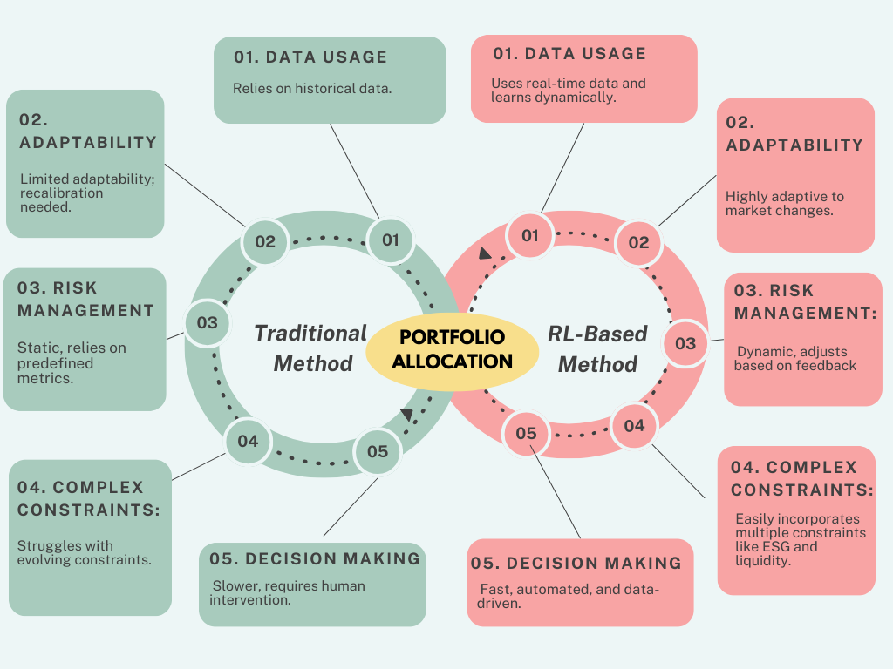
1.2.2 The role of risk management in investment strategies.
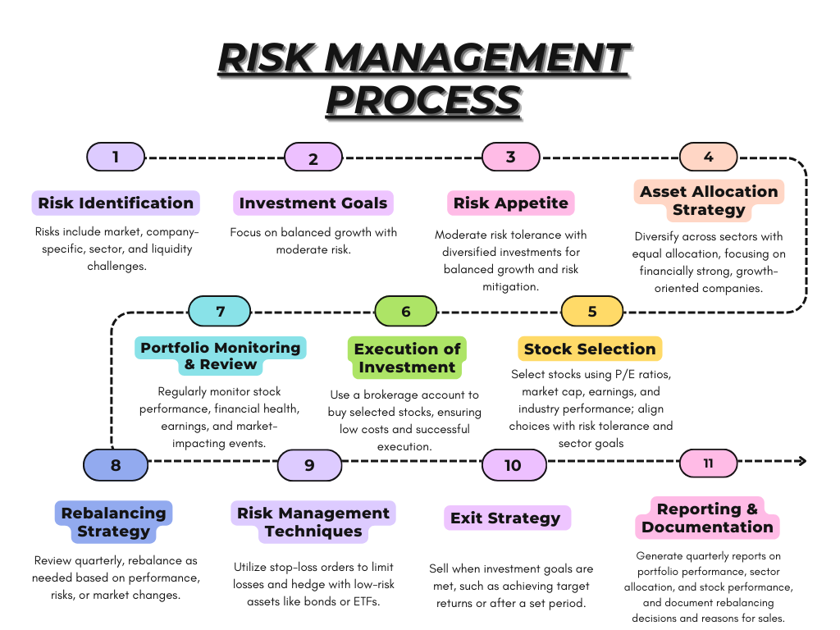

2. Defining the Problem @Tarun Samuel
Focus on challenges investors face with traditional portfolio allocation methods.
Explain the financial impact of poor risk management and how reinforcement learning addresses these challenges.
Answer here
Problem Definition: Enhancing Portfolio Management for Retail Traders
1. Identifying the Gap in the Market
Retail traders are at a disadvantage compared to institutional investors due to the lack of accessible, advanced tools for portfolio allocation and risk management. Most existing solutions are either too generic, offering static and pre-defined strategies, or too complex for non-professional users. This leaves a significant portion of retail traders underserved, leading to poor investment outcomes and dissatisfaction.
2. The Real-World Problem
Retail traders face specific challenges:
- Underperformance: Over 75% of retail traders lose money annually due to ineffective portfolio strategies and lack of diversification.
- Inadequate Risk Management: Many traders fail to incorporate dynamic risk-adjusted strategies, resulting in overexposure to volatile assets.
- Time and Knowledge Constraints: Retail traders often lack the expertise and time to make data-driven decisions, especially in fast-changing market conditions.
3. The Opportunity
- Growing Market: The global online trading market is expected to grow at a CAGR of 15%, fueled by the increasing popularity of trading apps among millennials and Gen Z.
- Demand for Advanced Tools: Surveys highlight that over 60% of retail traders are actively seeking tools for personalized portfolio management and risk assessment.
- Technological Advancements: AI and reinforcement learning have matured enough to provide scalable, robust solutions that were previously inaccessible to retail traders.
4. Target Audience
- Retail Traders: Individuals who actively invest in financial markets, ranging from beginners to intermediate-level traders.
- Tech-Savvy Millennials and Gen Z: These users prefer modern, AI-driven tools that simplify complex financial strategies.
- Part-Time Traders: Individuals who trade as a side activity and need tools to help manage their portfolios with minimal time investment.

3 Differentiation @ Riyo Sebastian
Competitor Analysis for FinRL: Portfolio Allocation and Management
Overview
Many techniques have been used to maximize return on investment and minimize potential losses in the stock market. Various platforms are providing solution for portfolio management. Here mainly focuses on the highly popular platform both traditional, the ones that doesn’t utilize ML techniques in their platforms and the nuance platform that implements ML techniques in their platforms.
Traditional Platforms (Non-ML)
1 MetaTrader (MT4/MT5)
MetaTrader 4, also known as MT4, is an electronic trading platform widely used by online retail foreign exchange speculative traders. It was developed by MetaQuotes Software and released in 2005.It primarily focuses on technical analysis and rule-based trading, lacking the ability to integrate machine learning for dynamic decision-making as well as to not designed to work full-time work in the stock market or exchange-traded futures.
Key Limitations:
- Rule-Based Trading:
It operates on fixed, rule-based strategies. Once a strategy is implemented, it remains static and cannot adjust to changes in market conditions or new data.
- Limited Support for Alternative Data Integration:
Mainly focused on price-based data and lacks tools for integrating different market indicators, market fluctuations, social media sentiment, news, or economic indicators.
- Inadequate Portfolio Management Tools:
It struggles with dynamic portfolio management such as dynamic asset allocation, risk-based management, and real-time portfolio optimization.
- Lack of Machine Learning Integration:
2 Interactive Brokers (TWS)
Provides professional-grade tools for global financial market trading via its Trader Workstation (TWS). The platform supports a wide range of asset classes, including stocks, options, futures, and forex. It is known for its low-cost structure and robust analytics but lacks inherent machine learning tools for strategy development and optimization.
Key Limitations:
- Complexity:
IBKR's Trader Workstation (TWS) is highly sophisticated and often seen as complex for newer traders or retail investors.
- Manual Strategy Development and Backtesting:
TWS allows for manual strategy development and backtesting, but it does not offer built-in machine learning making it time-consuming and challenging for advanced users to develop dynamic strategies.
- Limited ML Integration

3 Bloomberg Terminal
The Bloomberg Terminal is a computer software system provided by the financial data vendor Bloomberg L.P. that enables professionals in the financial service sector and other industries to access Bloomberg Professional Services through which users can monitor and analyze real-time financial market data and place trades on the electronic trading platform.
Key Limitations:
- Costs and Accessibility:
The Bloomberg Terminal is expensive, making it accessible only to large institutions, hedge funds, and high-net-worth individuals.
- Limited Machine Learning
- Inadequate Portfolio Management Tools:
It struggles with dynamic portfolio management such as dynamic asset allocation, risk-based management, and real-time portfolio optimization.
- Complexity:
The Bloomberg Terminal has complex interface, which can be overwhelming for newcomers or individual traders.

Brief Summary
The main limitations that can be seen in the traditional platforms are:
- Rule-based and static strategies that don’t adapt to changing market conditions.
- Limited ML integration, which hinders dynamic decision-making and real-time learning.
- Limited Support for Alternative Data Integration:
- Inadequate Portfolio Management Tools
- Inaccessibility and complexity, especially for retail traders.

2 Machine Learning (ML)-Powered Platforms

1 QuantConnect
QuantConnect is an algorithmic trading platform that allows users to design, backtest, and deploy machine learning-based strategies. It supports various asset classes and provides a comprehensive suite of data for backtesting. The platform integrates machine learning libraries (such as TensorFlow and scikit-learn) and facilitates strategies built using both traditional and machine learning models.
Key Limitations:
- Complex Setup and Development:
Developing and deploying ML-based strategies requires a deep understanding of both finance and machine learning.
- Resource-Intensive:
Developing and running machine learning algorithms on QuantConnect can be computationally expensive, especially when using complex models.
- Limited Built-In ML Algorithms:
While QuantConnect provides the tools for users to integrate ML models, it doesn’t offer many pre-built ML strategies or solutions. Most of the work is left to the users.
2 Alpaca
Alpaca is a commission-free trading platform with an API that allows users to integrate their own machine learning models for algorithmic trading. It offers a streamlined way to access stock trading and provides data for backtesting, as well as a flexible API that supports integration with popular ML libraries like TensorFlow and PyTorch.
Key Limitations:
- Native ML Support:
Alpaca does not come with built-in ML or AI algorithms for strategy development. Users need to build their own models from scratch.
- Requires Custom Development:
While Alpaca’s API is flexible, it requires users to have a solid understanding of both programming and machine learning to develop effective trading strategies.
- Limited Risk Management Tools:
Alpaca is more focuses more on the trading aspect and does not offer built-in tools for advanced portfolio risk management or optimization.

3 Quantopian
Quantopian was a widely popular algorithmic trading platform that allowed users to create and backtest machine learning-based strategies using Python. It provided access to a wealth of financial data and an integrated environment for strategy development. However, Quantopian has been discontinued, with its research and backtesting tools now integrated into other platforms like QuantConnect.
Key Limitations:
- Platform Discontinuation
- Dependence on External Brokerage
Quantopian required users to integrate with external brokers for real-world trading, adding complexity to the deployment of live strategies.
- Lack of Focus on Portfolio Optimization:
It primarily focused on developing and backtesting individual trading algorithms but didn’t provide the depth of portfolio management and optimization unlike FinRL.

Brief Summary
The main problems that these platforms experiences are:
- Complexity in development and lack of pre-built solutions.
- Inconsistent support for portfolio optimization and risk management.
- Need for custom code and integration of ML models from scratch.
By focusing on the combination of machine learning, reinforcement learning, and portfolio optimization, FinRL offers a competitive advantage over these platforms, providing more dynamic, efficient, and cost-effective solutions for traders looking to integrate AI-driven strategies into their workflows.

Comparison

Platform | Limitations | How FinRL Stands Out
MetaTrader (MT4/MT5) | - Static rule-based systems with limited adaptability.  - Inadequate portfolio management tools.  - Limited support for alternative data. | - RL adapts dynamically to market changes.  - Advanced portfolio optimization.  - Integrates alternative data sources.
Interactive Brokers (TWS) | - Requires manual strategy design and testing.  - Limited ML integration for dynamic adjustments. | - Automates backtesting and strategy development.  - RL continuously adjusts strategies in real-time.
Bloomberg Terminal | - Prohibitively expensive for individuals.  - Lacks robust ML features.  - Complex interface for non-professionals. | - Open-source and cost-effective.  - RL ensures real-time optimization.  - Simplified, modular interface for ease of use.
QuantConnect | - Steep learning curve for beginners.  - Resource-intensive for complex strategies.  - Limited built-in ML algorithms. | - Ready-to-use RL templates.  - Lower computational overhead.  - Pre-built RL algorithms for portfolio optimization.
Alpaca | - Limited native ML support.  - Requires significant custom development.  - Limited risk management tools. | - RL-powered portfolio optimization and risk management.  - Pre-built ML algorithms save time.  - Unified development platform.

4 Data Gathering and Insights @ Rajkaran Yasodhadevi Ponnuvelusamy
4.1Collect datasets from the given links (FinRL GitHub and Yahoo Finance). - paste screenshots
4.2Document dataset details (size, type, features).
Answer here

5 Analyze the data to identify patterns and visualization for analysis, @ Jobina Joy and @Anand Chathananickal Sajeevan
such as:
Use tools like Python, pandas, or NumPy
Create graphs, heatmaps, or visualizations for:
Stock price trends.
Portfolio performance comparisons.
Risk-return scatter plots.
Anand:
Second Analysis performed is to identify clearly how one sector affects the other.
For understanding the relation have taken one high valued ticker (high close*volume value) from each sector.
High valued tickers from each sector are:
Ticker | Sector
ABX.TO | Basic Materials
BCE.TO | Communication Services
ATD.TO | Consumer Cyclical
DOL.TO | Consumer Defensive
CNQ.TO | Energy
BMO.TO | Financial Services
BHC.TO | Healthcare
CNR.TO | Industrials
CIGI.TO | Real Estate
BB.TO | Technology
AQN.TO | Utilities

Graph
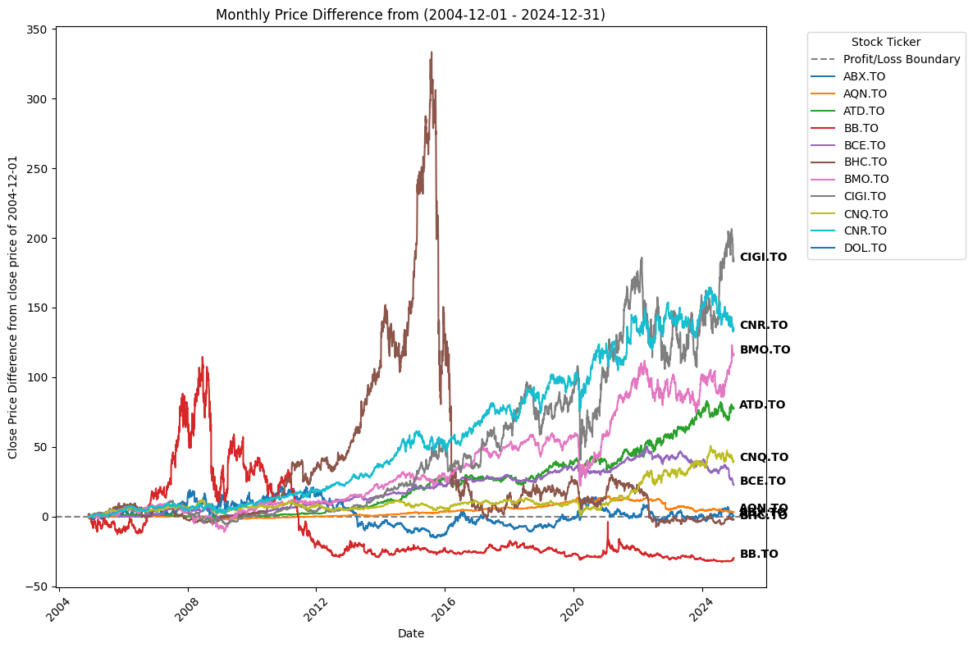
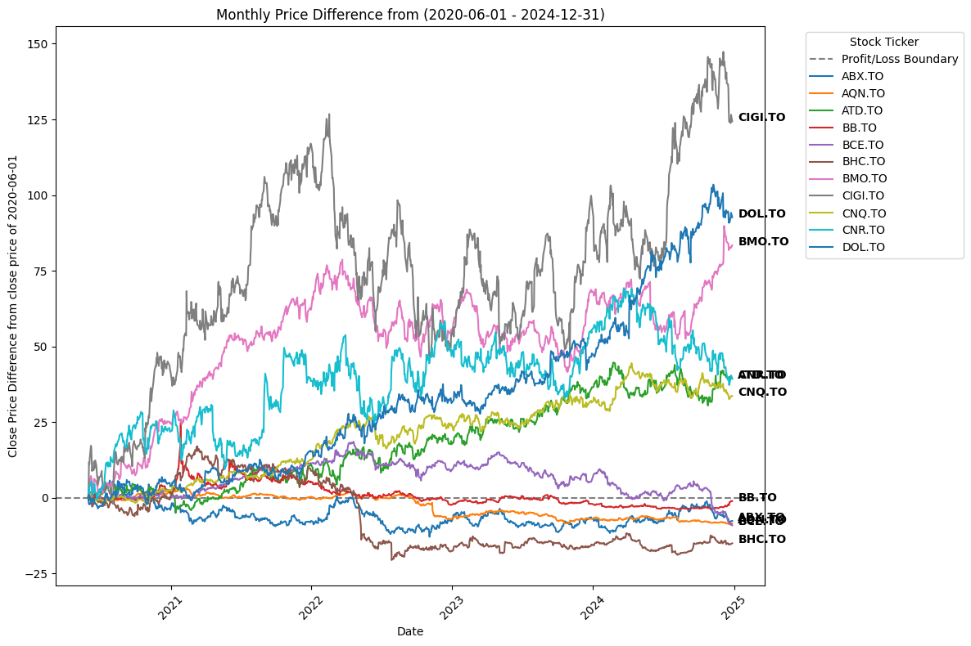
Observations:
- Impact of Economic Events
- Economic downturns (e.g., 2008 and 2020) are visible as dips in most stock trends, particularly cyclical sectors (e.g., energy and financials).
  - Insight: Defensive sectors (like utilities) maintain stability even during crises.
  - Customer Guidance: Recommend sector rotation into defensive sectors during periods of economic uncertainty.
- Long-Term Outperformers
- CIGI.TO and CNR.TO: Stand out as leaders with exponential growth over the long term.
- Insight: These stocks likely belong to sectors benefiting from long-term structural growth trends.
- Customer Guidance: Highlight these stocks for long-term investors focused on capital appreciation.
- Risk vs. Stability
- High-Risk Tickers: BB.TO and ABX.TO demonstrate extreme volatility, which could yield high rewards or significant losses.
  - Best suited for aggressive investors with high risk tolerance.
- Stable Growth Tickers: BCE.TO, BMO.TO, and ATD.TO offer steady returns, making them safer options for conservative investors.
  - Recommend these for income-focused or risk-averse users.
- Highly Volatile Stocks
- BB.TO and ABX.TO: Exhibit significant fluctuations and periods of steep decline (e.g., during economic downturns like 2008 and 2020).
  - Insight: These are likely in cyclical sectors (e.g., technology or mining), reacting strongly to market sentiment and macroeconomic factors.
  - Customer Guidance: Recommend for short-term, high-risk investors or those tracking specific market trends (e.g., gold price fluctuations for ABX.TO).
- Strong Performers
- CIGI.TO: Exhibits significant price growth, especially after 2016, indicating consistent upward momentum and strong sector performance (possibly real estate or growth-focused).
  - Insight: Suitable for investors seeking high-growth stocks.
- CNR.TO and BMO.TO: Show stable and consistent growth over the years, indicating resilience and potential for long-term investments.
  - Insight: Ideal for investors with moderate risk tolerance aiming for steady growth.
Sector Analysis and Connections
- Financial Sector (e.g., BMO.TO)
  - Connection to Energy:
Financial institutions are often exposed to the energy sector through lending and investments. A downturn in energy prices (affecting stocks like CNQ.TO) can lead to increased loan defaults or reduced profits for banks.
  - Connection to Real Estate:
Financial health influences real estate investment activities. A positive outlook in financials may lead to growth in real estate sectors like CIGI.TO.
- Energy Sector (e.g., CNQ.TO)
  - Connection to Industrial:
Energy prices directly affect operational costs in the industrial sector (e.g., CNR.TO). Rising energy prices may reduce profit margins for industrial companies.
  - Connection to Consumer Staples:
High energy prices often lead to increased transportation and production costs, indirectly raising prices for consumer goods (e.g., ATD.TO).
- Industrial Sector (e.g., CNR.TO)
  - Connection to Consumer Discretionary:
As industrial activity increases, transportation and logistics costs (affected by stocks like CNR.TO) can impact discretionary spending by consumers.
- Gold & Mining Sector (e.g., ABX.TO)
  - Connection to Financials:
Gold prices often rise during economic uncertainty, leading to reduced confidence in financial stocks. Investors tend to shift from financial instruments to safe-haven investments like gold.
  - Inverse Relationship to Growth Sectors:
Gold typically performs well during downturns, while growth sectors (e.g., tech like BB.TO) may underperform.
- Technology Sector (e.g., BB.TO)
  - Connection to Financials:
Technology companies rely on funding and capital from financial institutions. If financials are under stress, investment in tech companies may slow down.
  - Connection to Consumer Spending:
Tech adoption is closely tied to consumer discretionary spending. Economic stress (affecting consumer staples) can reduce demand for technology.
- Consumer Staples (e.g., ATD.TO)
  - Connection to Industrial and Energy:
Rising industrial and energy costs can reduce profit margins for consumer staple companies as raw material and logistics expenses increase.
  - Connection to Gold:
Consumer staples and gold often perform well during downturns, as they represent stability and essential goods.
- Real Estate Sector (e.g., CIGI.TO)
  - Connection to Financials:
Real estate activity is heavily dependent on the financial sector's lending environment. High interest rates can reduce borrowing and hurt real estate investments.
Insights for the Investor
- Energy as a Catalyst: Changes in energy prices can have ripple effects across financials, industrials, and consumer staples. Investors should monitor energy sector performance to anticipate broader market impacts.
- Gold as a Hedge: Gold is negatively correlated with growth and financial sectors. It is a reliable hedge during market volatility.
- Sector Synergies:
  - Financials and real estate are closely linked; growth in one often supports the other.
  - Industrials and energy share a direct cost relationship; rising energy prices can reduce industrial profits.
Portfolio Diversification: Ensure exposure across unrelated sectors (e.g., financials, gold, and consumer staples) to minimize risks from sector-specific downturns.
Jobina:
Analysis and Insights
Monthly cost price difference – Taken top 6 high valued tickers (highest Volume* Close value) or company to understand the cost price deflection compared to the cost price of the start day.
Top 6 high valued sectors are:
Sector | Name | Sector | Industry
CNQ.TO | CDN NATURAL RES | Energy | Oil & Gas E&P
BMO.TO | BANK OF MONTREAL | Financial Services | Banks - Diversified
CM.TO | CANADIAN IMPERIAL BANK OF COMME | Financial Services | Banks - Diversified
CNR.TO | CANADIAN NATIONAL RAILWAY CO. | Industrials | Railroads
ABX.TO | BARRICK GOLD CORPORATION | Basic Materials | Gold
BNS.TO | BANK OF NOVA SCOTIA | Financial Services | Banks - Diversified
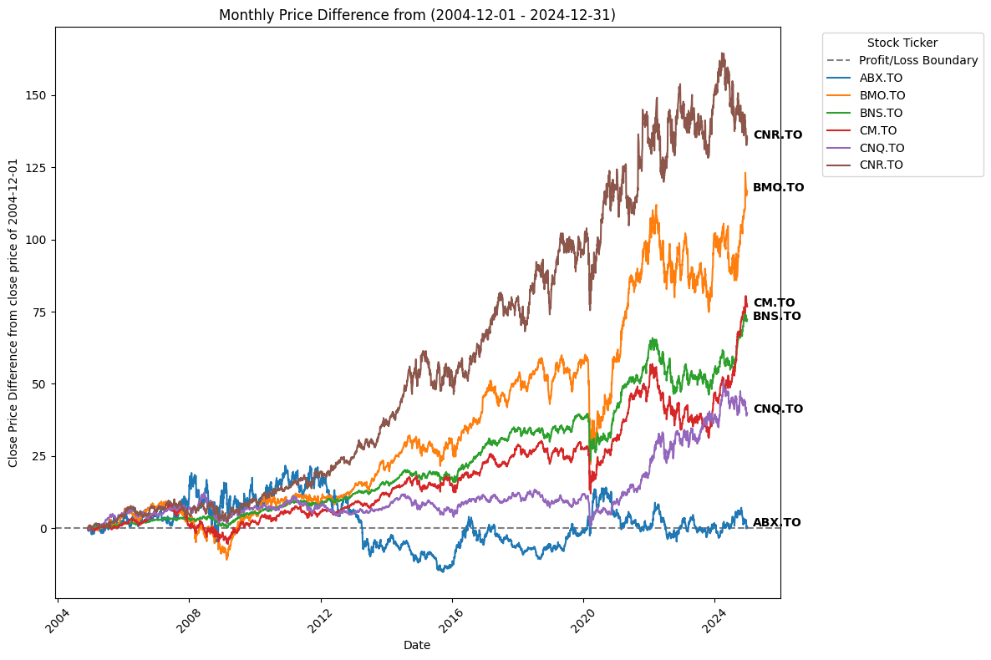
Observation from analysis:
- Sector which is highly valued are Oil & Gas E&P, Banks, Railway and Gold.
- Stock Growth Trends:
- The chart shows price differences from a base date (2004-12-01).
- Some stocks (like CNR.TO and BMO.TO) have experienced consistent long-term growth, making them strong candidates for stable investments.
- Others (like ABX.TO) have shown fluctuations, suggesting more volatility.
- Volatility and Risk:
- Stocks with higher price swings (e.g., ABX.TO) may be riskier but offer short-term trading opportunities.
- Stable stocks (e.g., CNR.TO) are more suited for long-term, low-risk investors.
- Investment Timing Matters:
- The 2008 and 2020 financial crises are visible as dips in stock prices.
- Investors who bought during these dips benefited from significant gains in the following years.
- Sector-Based Performance:
- Different stocks belong to different sectors.
- If a customer prefers low-risk investments, they should target sectors with steady upward trends.
- Profit/Loss Boundary (Dotted Line):
- It represents whether a stock is above or below its starting price.
- If a stock stays above the boundary for long periods, it indicates strong long-term performance.

How This Helps Beginner Investors:
Sector-Based Diversification to Reduce Risks:
- It means investing in different industries rather than putting all money into a single sector (e.g., technology, healthcare, finance).
- Different sectors react differently to economic changes, reducing overall investment risk.
Why is it important for new investors:
- If an investor only buys stocks from one sector (e.g., banking), their portfolio is at high risk if that sector crashes.
- Diversifying across multiple sectors protects against sector-specific downturns.
- For example:
Financial Sector (BMO.TO, CM.TO, BNS.TO) → Affected by interest rates, economic cycles.
Energy Sector (CNQ.TO) → Influenced by oil prices, geopolitical events.
Industrial Sector (CNR.TO) → Depends on trade, infrastructure growth.
Gold & Mining (ABX.TO) → Gains value in economic downturns (safe-haven investment).

How Can Beginners Use This?
- Scenario 1: If the economy slows down, banks (BMO.TO, CM.TO) might struggle, but gold (ABX.TO) could rise.
Scenario 2: If oil prices surge, energy stocks (CNQ.TO) will benefit, while transport (CNR.TO) may suffer due to higher costs.
- By investing across multiple sectors, losses in one area are balanced by gains in another.
7 Design wireframes: @ Jeffin Kochurani Ravi
8 Big Data Pipeline @ Anand Chathananickal Sajeevan

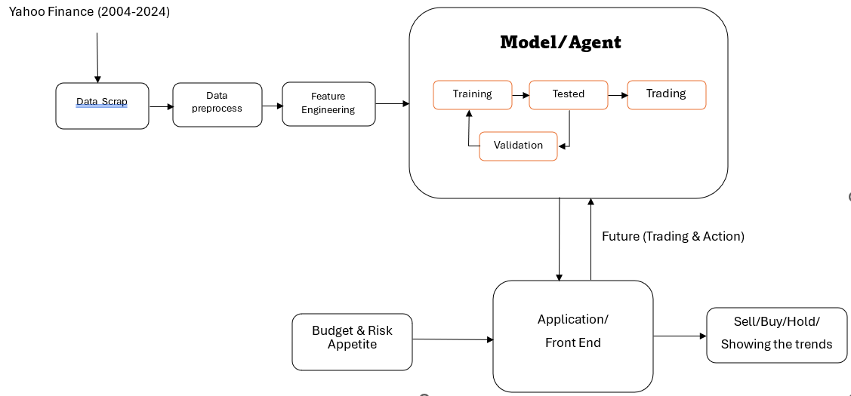
9 Data Exploration @jobina joy
Data Exploration

General Stock Data
- date: The date for the recorded stock data (e.g., daily).
- close: The closing price of the stock on the specified date.
- high: The highest trading price of the stock during the day.
- low: The lowest trading price of the stock during the day.
- open: The opening price of the stock on the specified date.
- volume: The total number of shares traded during the trading day.
- tic: The ticker symbol of the stock (a unique identifier for a company’s stock).
- day: The day index relative to the dataset (e.g., day 0, day 1).

Industry and Sector
- industry: The specific industry the company operates in (e.g., "Asset Management").
- sector: The broader sector of the company (e.g., "Financial Services").

Stock Metrics
- priceHint: Provides information on the level of granularity for stock prices (e.g., round to 1, 0.01).
- beta: A measure of volatility compared to the market (above 1 indicates higher volatility).
- regularMarketVolume: Volume traded during regular market hours.
- averageVolume: The average daily trading volume over a certain period.
- marketCap: Market capitalization, calculated as stock price × number of shares.
- fiftyTwoWeekLow: The lowest stock price in the past 52 weeks.
- fiftyTwoWeekHigh: The highest stock price in the past 52 weeks.

Valuation Metrics
- priceToSalesTrailing12Months: Price-to-sales ratio based on trailing 12-month revenue.
- fiftyDayAverage: The average stock price over the past 50 days.
- twoHundredDayAverage: The average stock price over the past 200 days.
- currency: The currency in which the stock is traded (e.g., USD).
- enterpriseValue: The total valuation of a company, including debt and equity.
- floatShares: The number of shares available for trading.
- sharesOutstanding: The total number of issued shares.
- sharesShort: The number of shares sold short (betting on a price decrease).
- sharesShortPriorMonth: The number of shares shorted in the previous month.
- sharesPercentSharesOut: The percentage of outstanding shares that are sold short.
- heldPercentInsiders: The percentage of shares held by insiders (e.g., executives).
- shortRatio: The ratio of shares short to average daily trading volume.
- impliedSharesOutstanding: The implied number of shares outstanding based on financial instruments.

Book Value and Profitability
- bookValue: The company’s book value per share (assets - liabilities).
- priceToBook: Price-to-book ratio (stock price compared to book value per share).
- netIncomeToCommon: The net income attributable to common shareholders.
- trailingEps: Earnings per share (EPS) over the trailing 12 months.
- lastSplitFactor: Ratio of the most recent stock split (e.g., 2:1).

Enterprise Ratios
- enterpriseToRevenue: Enterprise value compared to revenue.
- 52WeekChange: Percentage change in stock price over the past 52 weeks.
- SandP52WeekChange: Percentage change in the S&P 500 index over the past 52 weeks.

Dividends and Recommendations
- lastDividendValue: The value of the most recent dividend payment.
- quoteType: The type of security (e.g., "EQUITY").
- symbol: The stock ticker symbol (duplicate of "tic").
- shortName: A short name of the company.
- longName: The full name of the company.
- recommendationKey: Analyst recommendation (e.g., "buy," "hold").
- totalCash: Total cash held by the company.
- totalCashPerShare: Total cash per share.
- totalDebt: Total company debt.
- quickRatio: Liquidity ratio that measures a company’s ability to pay short-term obligations.
- currentRatio: Ratio of current assets to current liabilities.
- totalRevenue: Total revenue of the company.
- debtToEquity: Ratio of total debt to shareholders’ equity.

Profit Margins
- revenuePerShare: Revenue generated per share.
- returnOnAssets: Return on assets, showing profitability relative to assets.
- returnOnEquity: Return on equity, showing profitability relative to equity.
- grossProfits: Total revenue minus the cost of goods sold.
- freeCashflow: Cash available after operating expenses and capital expenditures.
- operatingCashflow: Cash generated from regular business operations.
- operatingMargins: Operating income as a percentage of revenue.

Risk and Growth Metrics
- financialCurrency: The currency used in financial reporting.
- trailingPegRatio: Price/earnings-to-growth ratio, adjusted for growth.
- forwardPE: Forward price-to-earnings ratio (based on future earnings).
- profitMargins: Net income as a percentage of revenue.
- heldPercentInstitutions: Percentage of shares held by institutional investors.
- forwardEps: Expected earnings per share in the future.
- enterpriseToEbitda: Enterprise value compared to EBITDA (earnings before interest, taxes, depreciation, and amortization).

Target Prices
- targetHighPrice: Analyst’s highest target price for the stock.
- targetLowPrice: Analyst’s lowest target price for the stock.
- targetMeanPrice: Analyst’s average target price for the stock.
- targetMedianPrice: Analyst’s median target price for the stock.
- recommendationMean: Average analyst recommendation score (1 = Strong Buy, 5 = Sell).
- numberOfAnalystOpinions: Number of analysts providing recommendations.

Additional Financial Metrics
- ebitda: Earnings before interest, taxes, depreciation, and amortization.
- revenueGrowth: Year-over-year growth in revenue.
- grossMargins: Gross profit as a percentage of revenue.
- ebitdaMargins: EBITDA as a percentage of revenue.

Risk Metrics
- auditRisk, boardRisk, compensationRisk, shareHolderRightsRisk, overallRisk: Various risk assessments (e.g., governance risks).

Dividend and Yield Data
- fiveYearAvgDividendYield: The average dividend yield over the past 5 years.
- trailingPE: Trailing price-to-earnings ratio.
- shortPercentOfFloat: Percentage of float shares sold short.
- dividendRate: Annual dividend payment per share.
- dividendYield: Dividend as a percentage of stock price.
- payoutRatio: Percentage of earnings paid as dividends.

Growth and Returns
- trailingAnnualDividendRate: Dividend rate over the trailing 12 months.
- trailingAnnualDividendYield: Dividend yield over the trailing 12 months.
- earningsQuarterlyGrowth: Growth in earnings compared to the same quarter last year.
- earningsGrowth: Growth in earnings over time.

Mutual Fund Data
- totalAssets: Total assets of a mutual fund.
- navPrice: Net asset value (NAV) price of a mutual fund.
- ytdReturn: Year-to-date return of a mutual fund.
- fundFamily: The fund’s family or group (e.g., Vanguard, BlackRock).
- legalType: The legal structure of the mutual fund (e.g., "Open-End Fund").
- yield: Yield of a mutual fund.

Average Returns
- threeYearAverageReturn: Average annual return over the past 3 years.
- fiveYearAverageReturn: Average annual return over the past 5 years.
beta3Year: Beta over a 3-year period.

FinRL: A Deep Reinforcement Learning Library for Financial Applications
Introduction
FinRL (Financial Reinforcement Learning) is an open-source library that applies deep reinforcement learning (DRL) techniques to financial market environments. It provides pre-built environments, datasets, and DRL algorithms to help researchers and practitioners develop portfolio allocation strategies. The library leverages cutting-edge machine learning techniques to model financial markets and optimize trading strategies.
Features of FinRL
1. Predefined Market Environments
- Stock Trading Environment: Simulates the buying and selling of stocks based on historical data.
- Cryptocurrency Trading Environment: Designed for digital assets like Bitcoin, Ethereum, and others.
- Portfolio Allocation Environment: Optimizes asset allocation across multiple stocks or financial instruments.
2. Multiple DRL Algorithms
- Deep Deterministic Policy Gradient (DDPG): Used for continuous action spaces, ideal for portfolio optimization.
- Proximal Policy Optimization (PPO): A policy-gradient method widely used for financial decision-making.
- Soft Actor-Critic (SAC): Incorporates entropy regularization to improve exploration.
- Twin Delayed DDPG (TD3): An improved version of DDPG that reduces overestimation bias.
- Advantage Actor-Critic (A2C): A model-free algorithm that balances exploration and exploitation.
3. Data Handling and Preprocessing
- Integrated Data Sources: Fetches historical stock data automatically from sources like Yahoo Finance.
- Technical Indicators: Pre-built indicators like MACD, RSI, and Bollinger Bands for feature engineering.
- Custom Feature Engineering: Users can define their own indicators and transformation pipelines.
4. Backtesting and Performance Evaluation
- Performance Metrics:
  - Sharpe Ratio: Measures risk-adjusted return.
  - Maximum Drawdown: Quantifies the worst peak-to-trough decline.
  - Volatility: Assesses market risk.
- Backtesting Framework:
  - Simulates trading in historical markets to estimate performance.
  - Plots cumulative returns to visualize strategy effectiveness.
5. Modular and Customizable Design
- Modify trading environments, implement new trading strategies, and integrate custom data sources.
- The modular design ensures flexibility for both beginners and advanced users.
6. Open Source and Community Driven
- Actively developed and improved by financial AI researchers and practitioners.
- Community contributions provide pre-trained models, tutorials, and documentation.
Installation
To install FinRL and its dependencies, run the following command:
pip install finrl
Additionally, install the required dependencies:
pip install gym stable-baselines3 pandas numpy matplotlib yfinance
Setting Up a Portfolio Allocation Project
Importing Required Libraries

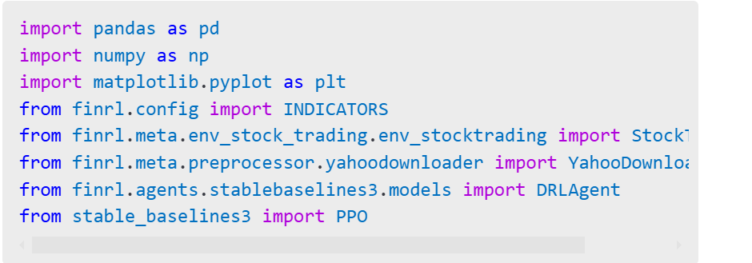
Downloading Market Data

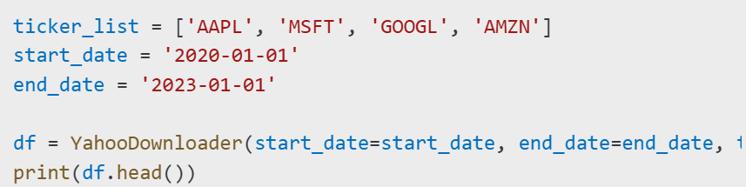
Feature Engineering

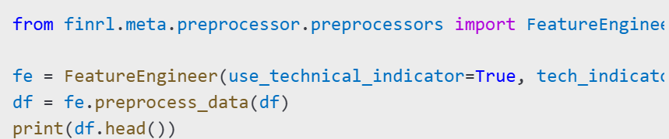

Creating the Trading Environment

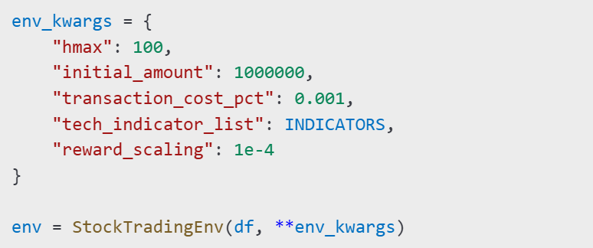

Training the DRL Model

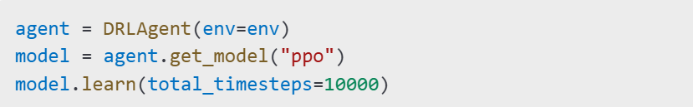

Backtesting the Strategy

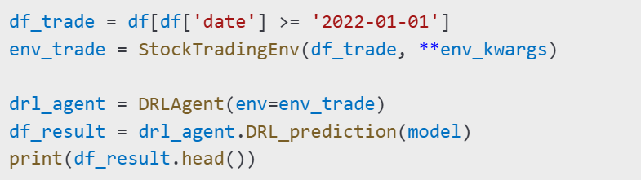

Evaluating the Model Performance

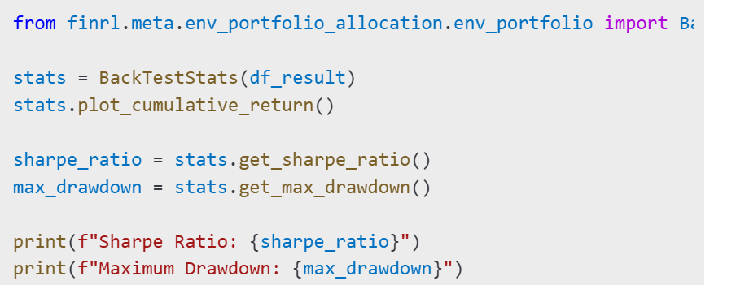

Deploying the Model
Paper Trading: Run the trained model on live market data in a simulated environment before actual deployment.
Live Trading: Integrate with brokerage APIs such as Alpaca or Interactive Brokers for real-time trading.
Conclusion
FinRL provides a structured framework for developing portfolio allocation strategies using deep reinforcement learning. It allows users to collect and preprocess financial data, train reinforcement learning models, and evaluate trading strategies through backtesting. With its modular design, FinRL enables researchers and financial practitioners to build, test, and deploy advanced AI-driven trading algorithms efficiently.

Understanding StockPortfolioEnv

StockPortfolioEnv: A Reinforcement Learning Environment for Portfolio Allocation
The StockPortfolioEnv class is a custom Gym environment designed for portfolio allocation using reinforcement learning. It simulates real-world trading by allowing an agent to allocate capital across multiple stocks, aiming to maximize portfolio returns while minimizing risk.

How to Call the Class
To use StockPortfolioEnv, we need to import it and initialize it with the required parameters.
For Eg:

from finrl.meta.env_portfolio_allocation.env_portfolio import StockPortfolioEnv

env = StockPortfolioEnv(
df=processed_stock_data,
stock_dim=10,
hmax=100,
initial_amount=1000000,
transaction_cost_pct=0.001,
reward_scaling=1e-4,
tech_indicator_list=['macd', 'rsi', 'cci', 'adx'],
turbulence_threshold=100,
lookback=252,
day=0
)

Parameters to Pass
- df: A DataFrame containing historical stock data with features like prices, indicators, and timestamps.
- stock_dim: Number of stocks in the portfolio.
- hmax: Maximum number of shares that can be traded at once.
- initial_amount: Initial capital available for investment.
- transaction_cost_pct: Percentage cost incurred in each transaction.
- reward_scaling: Factor for scaling rewards to prevent large variations.
- tech_indicator_list: List of technical indicators to be used.
- turbulence_threshold: A threshold to control risk management; above this, trading can be restricted.
- lookback: Number of past days used for decision-making.
- day: The starting day index in the dataset.

Stablebaseline3 @ RAJKARAN YASODHADEVI PONNUVELUSAMY

What is Stable-Baselines3?

Stable-Baselines3 is a popular Python library that provides implementations of reinforcement learning (RL) algorithms. These algorithms are designed to help machines learn how to make decisions by interacting with an environment and receiving feedback (rewards or penalties). It is like a toolbox with pre-built tools (algorithms) that can be used to train AI models to solve complex tasks, like playing games, controlling robots, or managing financial portfolios.
aaaaaaaaaaaaaaaaaaa
SB3 provides us with various algorithms like PPO, DDPG, TD3, A2C, SAC and more. These algorithms help the agent learn the best actions to take in different situations.

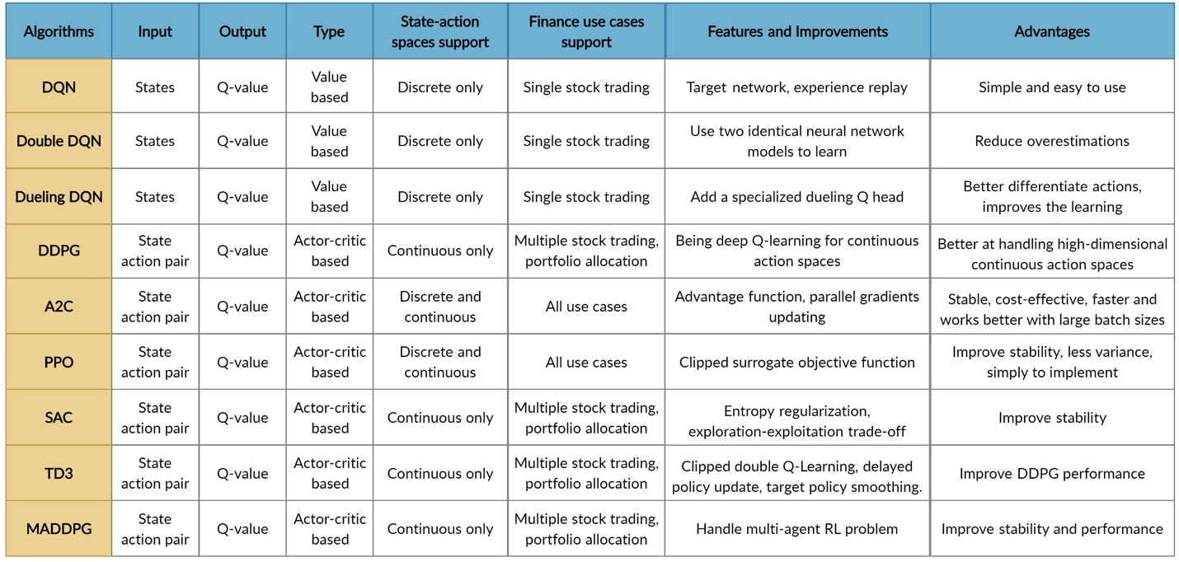

How Does Stable-Baselines3 Work?

In-order to understand this we need to know how Reinforcement learning works.

Reinforcement Learning Basics:

  - An agent (the AI model) interacts with an environment (e.g., a stock market simulation).

  - The agent takes actions (e.g., buying or selling stocks) based on the current state of the environment (e.g., stock prices, portfolio value).

  - After each action, the agent receives a reward (e.g., profit or loss) and moves to a new state.

  - The goal of the agent is to learn a policy (a strategy) that maximizes the total reward over time.

How SB3 works:

- Environment: We need to define or use an existing environment (e.g. from OpenAI Gym, Atari, robotics simulators, or custom environments) where our AI agent will interact. By interacting with the environment, the smart agent will derive a trading strategy to maximize the long-term accumulated rewards (aka; Q-value).

- Agent: Then we need to choose an algorithm from Stable-Baselines3 (e.g., PPO) to create an agent. FinRL's agents are built by fine-tuned standard DRL algorithms depending on three famous DRL library: ElegantRL, Stable Baseline 3, and RLlib.

- Training: This agent will then interact with the environment, collects experiences, and learns to maximize cumulative rewards by updating its policy.

- Evaluation: After training, we can evaluate the agent's performance in the environment.

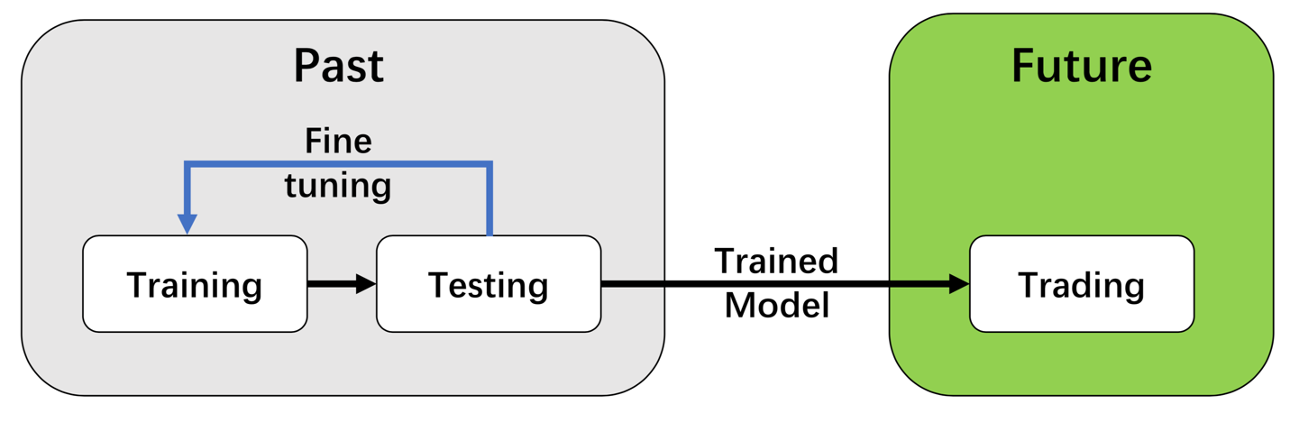

Why Use Stable-Baselines3 in FinRL?

- Ease of Use: Stable-Baselines3 provides pre-built algorithms, so you don’t need to code them from scratch.

- Flexibility: You can customize the environment, state, actions, and rewards to suit your specific needs.

- Performance: The algorithms are optimized for efficiency and can handle complex tasks like portfolio management.

Best RL Algorithms for our Portfolio Allocation Strategy (Less Compute-Intensive & Best for Portfolio Allocation)

Algorithm | Why Choose It? | Compute Intensity
Proximal Policy Optimization (PPO) | 🔹 Works well on large datasets.  🔹 Less compute-heavy than TRPO.  🔹 Stable learning, good for long-term strategies. | ⚡ Low-Medium
Twin Delayed DDPG (TD3) | 🔹 Handles continuous allocations.  🔹 More efficient than DDPG (avoids overestimation bias).  🔹 Optimizes risk-adjusted returns. | ⚡ Low-Medium
Soft Actor-Critic (SAC) | 🔹 Best for risk-sensitive portfolios.  🔹 Trades slightly higher compute cost for better stability. | ⚡ Medium
Advantage Actor-Critic (A2C) | 🔹 Efficient policy optimization.  🔹 Handles risk & reward trade-off well.  🔹 More lightweight than A3C. | ⚡ Low
Multi-Agent DDPG (MADDPG) | 🔹 Each stock/sector gets an individual AI agent to learn optimal strategies.  🔹 Good for sector diversification [e.g. Oil vs. Airlines]. | ⚡⚡⚡Very High

Value based algorithms like DQN and Double DQN are Not ideal for portfolio allocation. Use Policy-Based Methods instead.

Not Suitable algorithms for our Portfolio Allocation.

Algorithm | Reason for not choosing
Trust Region Policy Optimization (TRPO) | 🔹 Similar to PPO but slower.  🔹 More conservative updates → reduces volatility but is less scalable.
Deep Q-Network (DQN) | 🔹 Works for discrete actions (Buy/Sell).  🔹 Not ideal for portfolio allocation (doesn't support continuous weight adjustment).

Final Recommendation (Best Balance of Performance & Compute Efficiency)

Algorithm | Compute Cost | Portfolio Allocation | Sector Diversification | Handles Risk Appetite (Low/Medium/High)? | Final Verdict
PPO ✅ | ⭐⭐ (Moderate) | ✅ Excellent | ✅ Can add sector constraints | ✅ Handles risk via reward shaping | Best Overall Choice
TD3 ✅ | ⭐⭐ (Moderate) | ✅ Precise portfolio allocation | ✅ Can balance sectors | ✅ Handles risk by controlling action noise | Best for fine-tuning allocations
SAC ✅ | ⭐⭐⭐ (Moderate-High) | ✅ Risk-aware allocations | ✅ Ensures stable diversification | ✅ Uses entropy tuning for risk control | Best for adaptive risk management
A2C ❌ | ⭐ (Low) | ✅ Decent | ❌ Not explicitly industry-focused | ❌ Limited risk control | Too simple ❌
MADDPG ✅ | ⭐⭐⭐⭐ (Very High) | ✅ Excellent for multi-stock trading | ✅ Best for sector-based agents | ❌ Not designed for risk levels | Too compute-intensive ❌

Final Recommendation (Best Trade-Off)

PPO ✅ → Best overall for portfolio allocation, diversification, and risk control.
TD3 ✅ → Best for fine-tuning allocations across different risk levels.
SAC ✅ → Best for adaptive risk management (dynamically adjusts based on volatility).

PPO CODE EXPLANATION @ RAJKARAN YASODHADEVI PONNIVELUSAMY
PPO StockDataIterater Explanation:
General Intuition:
Why Iterators Are Used in Big Data Science Projects
In large-scale data science projects, iterators are essential for handling vast amounts of data efficiently without overwhelming memory. Here’s why they are widely used:
- Memory Efficiency: Instead of loading the entire dataset into memory, iterators process and return data in smaller batches, reducing memory consumption. This is crucial when dealing with high-dimensional financial data like stock prices, technical indicators, and trading volumes.
- Streaming Data Processing: In real-world applications like stock market forecasting, data is continuously updated. Iterators allow on-the-fly processing and training of models without requiring a complete dataset reload.
- Lazy Evaluation: Rather than computing everything upfront, iterators generate data on demand. This minimizes unnecessary computations and speeds up training processes in machine learning models.
- Scalability: When training reinforcement learning models like Proximal Policy Optimization (PPO), iterators help scale up by feeding manageable chunks of data into the training pipeline. This allows efficient processing of thousands of stocks over extended time frames.
- Batch Processing for Parallelization: Iterators allow batching, which enables parallel processing and vectorized computations, leveraging hardware acceleration (e.g., GPUs) for faster execution.
- Consistency in Sequential Data: In time-series problems like stock market predictions, iterators ensure that past data is accessed in a structured manner, maintaining temporal consistency while training models.
Explanation of StockPortfolioIterator
This iterator efficiently processes and structures stock market data for training a reinforcement learning model like PPO. It incorporates batching, feature engineering, scaling, and historical data lookback for predictive modeling.
1. Data Loading and Filtering
- Reads stock data from a CSV file and converts the date column into a datetime format.
- Filters out stocks that don’t have sufficient historical data (min_history threshold).
- Sorts data by date and stock ticker to maintain chronological order.
- Uses only the last train_years years of data, ensuring that outdated stock patterns don’t influence predictions.
2. Batch-Wise Feature Engineering
- Computes technical indicators (e.g., RSI, MACD, Momentum, Bollinger Bands) in smaller batches to prevent memory overflow.
- Uses rolling windows and exponential moving averages to generate meaningful trading signals.
- Updates the original dataset iteratively rather than modifying the entire dataset at once.
3. Robust Feature Scaling
- Clips extreme values using Interquartile Range (IQR) to mitigate the impact of outliers in financial data.
- Uses StandardScaler to normalize features, ensuring that they are comparable across different stocks.
- Applies scaling iteratively on batches to prevent unnecessary memory allocation.
4. Training Data Preparation for PPO
- Groups data by dates, allowing reinforcement learning models to be trained with time-sequenced information.
- Stores extracted features and stock prices in dictionaries (all_features and all_prices) to ensure quick access during training.
- Processes training data in small date batches, maintaining memory efficiency.
5. Iterator Mechanism for Efficient Data Feeding
- Implements __iter__() and __next__() methods to yield stock data in a sequential manner.
- Uses a lookback window mechanism to ensure that each batch contains historical stock information needed for reinforcement learning.
- Returns structured data in the form of features, stock prices, and tickers, making it directly usable for training PPO models.
6. Reset Functionality
- Provides a reset() method to restart the iterator from the beginning, which is useful in reinforcement learning scenarios where multiple training epochs are required.

How This Iterator Fits into Real-World Problems
- Stock Market Forecasting & Portfolio Optimization
  - The iterator structure allows PPO to learn from past stock data trends and generate optimal trading decisions based on historical price movements.
- Handling Large-Scale Financial Datasets
  - Processing 1,650 stocks over 20 years results in millions of data points. Using batch processing ensures that memory and computational resources are efficiently managed.
- Scalable Reinforcement Learning for Trading Bots
  - The structured data output (features and stock prices) is essential for training reinforcement learning agents that learn optimal asset allocations over time.
- Parallelization & Speed Optimization
  - The batch-wise approach enables leveraging multi-threaded or GPU-based computations, significantly reducing training time compared to processing all stocks at once.
- Adaptability for Live Market Data
  - By using an iterator, this approach can be extended to real-time stock data, allowing continuous model retraining as new market conditions emerge.

PPO ENVIRONMENT EXPLANATION:
PortfolioTradingEnv: Environment for Stock Portfolio Optimization
The PortfolioTradingEnv class is a reinforcement learning environment built using OpenAI Gym. It simulates stock portfolio management, allowing an RL agent to allocate capital dynamically across multiple assets.

Why This Environment is Used in Portfolio Optimization
- Realistic Market Simulation
  - The environment models how stock prices evolve over time and allows an agent to allocate funds dynamically.
- Transaction Costs Handling
  - Every trade incurs a transaction cost, making sure the agent learns optimal allocation strategies.
- Risk Management with Concentration Factor
  - Encourages meaningful diversification by penalizing overly spread-out allocations.
- Reinforcement Learning Compatibility
  - Designed for algorithms like PPO, which require structured states, actions, and rewards.

Key Components of the Environment
1. Initialization (__init__)
- Takes a data_iterator object to fetch stock data sequentially.
- Defines parameters like initial cash, transaction costs, and position concentration incentives.
- Creates Gym's action_space (portfolio allocations) and observation_space (stock features).
2. Reset Function (reset)
- Resets the environment to the start of a new episode.
- Resets cash, holdings, and reward tracking.
- Fetches the first batch of stock features and returns it as an observation.
3. Observations (_get_observation)
- Provides stock-related features over a lookback window.
- Helps the RL model learn historical patterns for better decision-making.
4. Concentration Reward (_calculate_concentration_reward)
- Encourages meaningful portfolio allocations instead of extreme diversification.
- Uses metrics like the Herfindahl-Hirschman Index (HHI) and effective number of positions.
- Higher rewards are given to portfolios that maintain a concentrated yet balanced allocation.
5. Step Function (step)
- Takes an action representing the allocation of cash and stocks.
- Ensures actions are properly normalized to sum to 1.
- Computes the portfolio value, transaction costs, and rewards.
- Moves to the next time step and provides updated observations.

How This Environment Helps in Real-World Financial Modeling
- Stock Market Portfolio Optimization
  - Enables reinforcement learning models to train on historical data and develop optimal allocation strategies.
- Scalability for Large Datasets
  - Can handle thousands of stocks efficiently using batched processing.
- Cost-Efficient Trading Strategies
  - Penalizes excessive transactions, teaching the RL agent to minimize trading costs.
- Better Risk-Adjusted Returns
  - The concentration factor ensures that the agent maintains a balance between diversification and focused investments.
- Live Market Adaptability
  - Can be extended to real-time trading by integrating with live stock market APIs.

ERRORS FACED :

Loaded 1568 stocks with 5281 trading days Using cpu device --------------------------------------------------------------------------- ValueError Traceback (most recent call last) <ipython-input-30-0f9256e351c6> in <cell line: 0>() 15 ) 16 ---> 17 model.learn(total_timesteps=15000) 4 frames /usr/local/lib/python3.11/dist-packages/stable_baselines3/common/vec_env/dummy_vec_env.py in _save_obs(self, env_idx, obs) 107 for key in self.keys: 108 if key is None: --> 109 self.buf_obs[key][env_idx] = obs 110 else: 111 self.buf_obs[key][env_idx] = obs[key] # type: ignore[call-overload] ValueError: could not broadcast input array from shape (275,30,7) into shape (1568,30,7)

Loaded 1568 stocks with 5281 trading days Using cpu device --------------------------------------------------------------------------- TypeError Traceback (most recent call last) <ipython-input-5-401a34708cdf> in <cell line: 0>() 2 train_env = DummyVecEnv([lambda: PortfolioTradingEnv(train_iter)]) 3 model = PPO("MlpPolicy", train_env, learning_rate=1e-4, n_steps=2048, batch_size=256, n_epochs=10, gamma=0.99, verbose=1) ----> 4 model.learn(total_timesteps=15000) 3 frames /usr/local/lib/python3.11/dist-packages/stable_baselines3/common/vec_env/dummy_vec_env.py in reset(self) 76 for env_idx in range(self.num_envs): 77 maybe_options = {"options": self._options[env_idx]} if self._options[env_idx] else {} ---> 78 obs, self.reset_infos[env_idx] = self.envs[env_idx].reset(seed=self._seeds[env_idx], **maybe_options) 79 self._save_obs(env_idx, obs) 80 # Seeds and options are only used once TypeError: PortfolioTradingEnv.reset() got an unexpected keyword argument 'seed'

PPO RECOMMENDER CLASS:
OVERVIEW:
The PortfolioRecommender class is designed to generate stock portfolio recommendations based on historical market data. It uses a trained Proximal Policy Optimization (PPO) reinforcement learning model to determine the best asset allocations. The class processes market data, extracts relevant stock features, and uses the trained model to generate a portfolio allocation that optimizes returns while managing risk.

Initialization and Data Preprocessing
- Loading the Model
When the class is initialized, it loads a trained PPO model. The model’s observation space determines the exact number of stocks it expects for making predictions.
- Loading Market Data
The historical stock data is read from a CSV file, and the most recent available date in the dataset is identified. This helps ensure that portfolio recommendations are based on the latest market conditions.
- Filtering Stocks
The model requires a fixed number of stocks with sufficient historical data. Stocks with at least lookback + 10 days of trading history are selected. If too many stocks qualify, they are filtered based on trading volume, as higher-volume stocks are generally more liquid and stable.
  - If fewer than the required number of stocks are available, additional tickers are added from the dataset.
  - If even that is insufficient, dummy tickers are introduced to maintain the expected input size for the model.
- Fetching Latest Prices
The latest closing prices of the selected stocks are stored for later use in calculating allocations. If a stock is missing a recent price, the most recent available price is used. Dummy stocks are assigned a default price of $1.00.

Feature Engineering
- Technical Indicators
To make meaningful predictions, the model requires technical indicators for each stock over the lookback period. These include:
  - Returns (percentage change in price)
  - Moving Averages (average price over a period)
  - Relative Strength Index (RSI) (measures momentum)
  - MACD (trend-following indicator)
  - Volatility (standard deviation of returns)
  - Momentum (rate of price change)
  - Bollinger Bands (upper and lower bounds based on volatility)
- Handling Missing Data
If a stock has insufficient historical data, missing values are replaced with zeros or reasonable defaults (e.g., RSI set to 50). This prevents issues when passing the data to the model.

Generating Portfolio Recommendations
- Predicting Allocations
The preprocessed features are fed into the PPO model to generate an action vector that represents the percentage of funds allocated to each stock.
- Normalizing Allocations
Since reinforcement learning models can output values beyond the expected range, the allocation percentages are clipped to ensure they sum to 100%. If the model produces only zero allocations, the entire investment is allocated to cash.
- Distributing the Investment Amount
The recommended allocation percentages are used to distribute the input investment amount. For each stock:
  - The model determines the percentage of the total amount to allocate.
  - The number of shares to purchase is calculated based on the stock’s latest price.
  - Small allocations (less than 0.5%) and dummy tickers are ignored.
- Summarizing Results
Finally, the function returns a structured output with:
  - Cash allocation (if any)
  - Stock allocations (ticker, percentage, dollar amount, shares)
  - Overall investment details
The results also include the date of recommendation to ensure the allocations are based on up-to-date data.

Key Takeaways
- The class ensures the input data matches the model’s requirements by handling missing stocks and filling gaps.
- It extracts meaningful financial indicators to provide the model with relevant market information.
- The recommendation process normalizes allocations, preventing the model from making extreme or unrealistic decisions.
- The output is structured and detailed, making it easy to interpret and use for portfolio allocation.

TRAIN FUNCTION EXPLANATION :
Overview:
The train_model function is responsible for training a Proximal Policy Optimization (PPO) model for stock portfolio optimization. It follows a structured process to ensure stable and efficient training. Below is a detailed breakdown of its execution:

1. Initialization & Data Preparation
- The function starts by printing a message indicating the training process has begun, along with the current timestamp.
- A StockPortfolioIterator is initialized to handle the stock market data. This iterator:
  - Loads stock data from the given file path.
  - Uses a lookback window to capture historical trends for decision-making.
  - Requires a minimum history of 50 days before training can begin.
  - Uses a batch size that includes all available stocks to maximize learning efficiency.
  - Limits training to 20 years of data to ensure comprehensive learning.
- After initializing the iterator, the function prints the number of stocks included in training.

2. Creating the Training Environment
- A custom PortfolioTradingEnv environment is created, where the model interacts with simulated financial markets.
- The environment is wrapped using DummyVecEnv, which allows stable vectorized training.
- This setup ensures that the model can learn from multiple stock portfolios at once.

3. Defining the PPO Model
- A SimpleStockPolicy is used as the policy network, which simplifies computations and enhances numerical stability.
- Key hyperparameters for PPO are set, including:
  - Learning Rate: Controls how fast the model updates its policy.
  - Steps per Update (n_steps): Defines how many steps the agent takes before performing a policy update.
  - Batch Size (batch_size_ppo): Determines how many experiences are used per training iteration.
  - Discount Factor (gamma): Controls how much future rewards influence present decisions.
  - Entropy Coefficient (ent_coef): Regulates exploration versus exploitation.
  - Gradient Clipping (max_grad_norm): Helps stabilize training by preventing excessive parameter updates.
- The policy network is structured with two hidden layers of 128 neurons each for both the policy and value functions.
- The Adam optimizer is used with specific settings to improve stability.
- TensorBoard logging is optional and enabled if requested.

4. Model Training
- The model is trained for the specified number of timesteps (500,000), meaning it will interact with the environment that many times.
- The training is wrapped in a try-except block to catch potential errors and ensure progress isn't lost.
- If training completes successfully:
  - The final model is saved to the specified path.
  - A completion message is printed with the timestamp.
- If an error occurs:
  - The function attempts to save a partial model to prevent data loss.
  - If saving the partial model fails, an error message is printed.

5. Output
- The trained PPO model is returned for further evaluation or deployment.
- The function ensures robustness by handling errors gracefully and saving progress even if something goes wrong.

Overall, Purpose
This function trains a PPO-based reinforcement learning model to optimize stock portfolio management. It ensures that:
- The model learns from a large set of stocks over a long historical period.
- Training is stable and efficient with proper parameter selection and numerical safeguards.
- Progress is not lost in case of errors, thanks to built-in error handling and model-saving mechanisms.
This structured approach ensures that the model is well-trained and ready for real-world financial decision-making.

ERRORS FACED IN TRAIN FUNCTION:
Preprocessing data... Processing stocks: 0%| | 0/1190 [00:00<?, ?it/s] --------------------------------------------------------------------------- ValueError Traceback (most recent call last) <ipython-input-3-32abaf57574a> in <cell line: 0>() 1 if __name__ == "__main__": 2 # Train on full dataset ----> 3 train_model("/content/historical_data.csv", "1650_stock_model") 4 5 # Generate recommendations 7 frames /usr/local/lib/python3.11/dist-packages/pandas/core/common.py in require_length_match(data, index) 571 """ 572 if len(data) != len(index): --> 573 raise ValueError( 574 "Length of values " 575 f"({len(data)}) " ValueError: Length of values (5020) does not match length of index (5021)

PPO BACKTEST EXPLANATION:
Overview:
The backtest_portfolio function simulates how a reinforcement learning-based trading strategy would have performed over a specified historical period. It evaluates the model's ability to allocate capital across multiple stocks while tracking key performance metrics such as returns, volatility, transaction costs, and drawdowns.

Backtest Setup
- Initializing the Backtest Environment
  - The function first sets up a backtesting environment by loading stock data from a historical dataset.
  - It ensures that only stocks with sufficient historical data are included in the simulation.
  - The StockPortfolioIterator component is used to feed historical stock data to the model, and a PortfolioTradingEnv is created to simulate the trading environment.
  - The starting portfolio value is set to $10,000, but this can be adjusted.
- Tracking Key Metrics
Several lists are initialized to track portfolio performance over time, including:
  - Portfolio values (total portfolio worth over time)
  - Returns (daily percentage changes in portfolio value)
  - Cash allocations (how much of the portfolio remains in cash)
  - Transaction costs (costs associated with buying and selling stocks)
  - Holdings diversification (how many different stocks are held at a given time)
  - Daily turnover (how frequently the portfolio composition changes)

The function also tracks trading dates for time-series analysis.

Running the Backtest
- Simulation Loop
  - The function enters a loop where it repeatedly asks the reinforcement learning model to predict asset allocations based on current market conditions.
  - The action returned by the model determines how much capital is allocated to each stock and how much remains in cash.
  - The environment then executes the trade, and the function records the resulting portfolio value, returns, and transaction costs.
  - The loop continues until the simulation period is complete.
- Tracking Portfolio Performance
  - The function periodically prints updates on the portfolio’s value and returns.
  - If the simulation is interrupted, the function gracefully stops and processes the available results.
- Transaction Cost Handling
  - The function calculates transaction costs after each step, which helps measure how much of the portfolio's value is lost due to trading fees.
  - It also computes daily turnover, representing the percentage of the portfolio that was changed each day.

Performance Metrics Calculation
Once the backtest is complete, several performance metrics are computed:
- Total return: The overall percentage gain or loss over the backtest period.
- Annualized return: The average yearly return, adjusted for time.
- Volatility: Measures how much the portfolio's value fluctuates.
- Sharpe ratio: A risk-adjusted return metric (higher values indicate better risk-adjusted performance).
- Maximum drawdown: The worst peak-to-trough decline in portfolio value.
- Win rate: The percentage of days where the portfolio had a positive return.
- Average cash allocation: The percentage of the portfolio kept as cash, providing insight into risk exposure.
- Average number of holdings: The average number of stocks held at any given time.
- Daily turnover: Measures how frequently the portfolio composition changes.

Results and Summary
- The final results, including the portfolio's value at the end of the simulation, are printed.
- A time-series dataframe is created to store the portfolio’s daily values, cash allocations, transaction costs, and number of holdings.
- The function then returns a dictionary containing all relevant backtest data, allowing for further analysis or visualization.

Key Takeaways
- The function simulates how the reinforcement learning model would perform in a real-world trading environment.
- It ensures that the backtest is conducted using historical stock data while enforcing realistic constraints such as transaction costs.
- The function provides a detailed breakdown of the model’s performance, making it easy to assess whether the strategy is viable for live trading.
- By analyzing various performance metrics, we can determine whether the model effectively balances risk and reward over time.

STRESS TEST EXPLANATION:
The stress_test_portfolio function is a comprehensive method designed to assess how a portfolio model performs under various market conditions. Let's break it down step by step:
1. Function Parameters:
- model: This is the portfolio model to be tested.
- data_path: The path to the dataset containing historical stock data.
- lookback: The number of past data points to consider when performing backtests (default is 30 days).
- initial_cash: The initial amount of cash available for the portfolio (default is $10,000).
- batch_size: The number of stocks to process at a time (default is 1650).
2. Initial Setup:
- Prints a message to indicate that stress tests are starting.
- Initializes a dictionary stress_test_results to store the outcomes of the tests.
3. Data Loading and Preprocessing:
- The function loads the dataset (data_path) into a Pandas DataFrame and processes the date column to extract the year.
- Observation Shape: The shape of the model’s observation space is checked to determine how many stocks the model expects. This is used to filter the dataset to match the model's training data (i.e., matching the number of stocks).
- Filter by Ticker Volume: Stocks are sorted by their average volume, and only the top expected_num_stocks (the number the model expects) are selected for the test.
- If filtering results in an empty dataset or if the dataset lacks necessary date columns, the function returns an error message.
4. Bear Market Test:
- Purpose: This test evaluates how the portfolio model performs during a bear market (a market characterized by declining prices).
- The function calculates yearly returns based on a market index (average closing price of all stocks).
- It identifies the worst year in terms of returns and attempts to gather the data for that year.
- If sufficient data is available, it processes the data by filling missing stock data using forward and backward filling methods. If no data for a stock exists, default values are assigned (e.g., close = 1.0).
- It then backtests the model using this filtered dataset from the worst year.
- Any issues during this process (e.g., missing data or backtest failures) are caught, and an error message is stored in stress_test_results.
5. High Volatility Test:
- Purpose: This test evaluates how the portfolio performs during periods of high market volatility.
- It calculates monthly returns from the average daily closing price and identifies the most volatile period based on the standard deviation of returns over 3-month windows.
- If enough data is available, it identifies the most volatile quarter (a 3-month period) and creates a dataset for this period, again filling missing values as necessary.
- It then backtests the model on this high-volatility data.
- Similar to the bear market test, any issues encountered during this test (e.g., insufficient data or backtest failures) are caught and reported.
6. Error Handling and Robustness:
- Throughout the process, the function has error handling mechanisms in place:
  - It checks for missing or insufficient data.
  - If any errors occur during the setup, data preparation, or backtesting (e.g., missing values or issues with the model), they are caught and stored in the stress_test_results dictionary.
  - Detailed messages are printed, which help in understanding which step failed or if there was insufficient data for the test.
7. Results Summary:
- After performing the tests, the function prints a summary of the results for each stress test (bear market and high volatility). If the test was successful, it prints key performance metrics such as:
  - Total return
  - Annualized return
  - Maximum drawdown
  - Sharpe ratio
- If any test failed, an error message is displayed instead.
8. Temporary Files:
- The function uses temporary CSV files (temp_bear_market.csv, temp_high_vol.csv) to store intermediate datasets for the bear market and high volatility tests. These are generated during the tests and used for backtesting the portfolio model.

Overall Objective:
- The primary goal of this function is to stress test the portfolio model under different market conditions, ensuring that the model is robust and capable of handling adverse conditions such as a bear market and high volatility.
- By simulating real-world scenarios, the function provides insights into how the model would perform in different market environments, helping to assess its effectiveness and reliability.

EVALUATION FUNCTION EXPLANATION:

- Function Input Parameters:
  - model: This is the trained model that will be evaluated.
  - data_path: The path where the dataset is located.
  - lookback: The number of past time steps to consider for making predictions. In this case, 30.
  - episodes: The number of evaluation episodes to run. An episode represents a full cycle of training/evaluation.
  - batch_size: The number of data samples processed in each batch.
  - min_history: The minimum number of past data points required to begin an evaluation.
- Initialization of Iterators and Environment:
  - eval_iter: An instance of StockPortfolioIterator is created with the provided parameters like the dataset location, lookback window, minimum history, and batch size. This object is responsible for iterating over the stock data and providing the necessary data for training/evaluation.
  - eval_env: The PortfolioTradingEnv object is initialized using eval_iter. It defines the simulation environment where the model will interact. It is essentially a trading environment that allows the model to take actions (buy, sell, hold) and observe the rewards and states.
- Evaluation Process (Loop over Episodes):
  - The function evaluates the model over multiple episodes (episodes parameter). Each episode represents one full run of the environment from start to finish.
  - For each episode:
    - The environment is reset with the reset() method, which initializes the state and provides the first observation (obs).
    - The model interacts with the environment, predicting actions using model.predict().
    - For each step in the environment:
      - The model chooses an action (action) based on the observation (obs).
      - The environment returns the next observation, the reward for the action, whether the episode is done (done), and additional info (like portfolio value).
      - The reward and portfolio value are accumulated over the steps of the episode.
    - The episode continues until a terminal condition is met (i.e., the done flag is set to True).
    - The final value of the portfolio at the end of the episode is stored, and metrics like Sharpe ratio and maximum drawdown are computed.
- Metrics and Performance Calculation:
  - After each episode, the total reward, final portfolio value, and annualized return are calculated. The annualized_return is a performance metric that normalizes the return to a yearly rate.
  - The function prints the results for each episode, including the total reward, number of steps, final portfolio value, and annualized return.
- Aggregating Results Across Episodes:
  - The function calculates the following summary statistics across all episodes:
    - Average Total Reward: Mean of total rewards accumulated across all episodes.
    - Average Final Portfolio Value: Mean of final portfolio values across all episodes.
    - Success Rate: Percentage of episodes where the total reward is positive (i.e., profitable).
    - Average Sharpe Ratio and Maximum Drawdown: These metrics are calculated by averaging the values for each episode.
- Output:
  - The function prints the aggregated results, providing insights into the overall performance of the model.
  - The function returns a dictionary containing:
    - total_rewards: List of rewards for each episode.
    - portfolio_values: List of final portfolio values for each episode.
    - avg_reward: The average reward across all episodes.
    - avg_final_value: The average final portfolio value across episodes.
    - success_rate: The percentage of episodes with a positive return.
    - avg_metrics: A dictionary containing the average values for specific metrics (e.g., Sharpe ratio, maximum drawdown).
Key Components:
- Portfolio Value: The total value of the portfolio after executing the model's actions in the environment. This is tracked for each episode and used to assess the overall performance.
- Sharpe Ratio and Maximum Drawdown: These financial metrics are used to evaluate the risk-adjusted return of the model. The Sharpe ratio measures the return relative to the volatility, while maximum drawdown tracks the largest peak-to-trough decline.
- Annualized Return: The function also calculates the annualized return based on the final value of the portfolio, normalizing it to a yearly scale to understand performance over time.
The hyperparameter_tuning function is designed to systematically search for the best hyperparameters for the Proximal Policy Optimization (PPO) model in a reinforcement learning-based stock portfolio optimization task. The function performs the following steps:
Key Steps in the Hyperparameter Tuning Process:
- Directory and Results Initialization:
  - The function begins by creating a directory (if it doesn't already exist) to store the models and results of the hyperparameter tuning process.
  - It generates a timestamped file name to store the tuning results in JSON format.

- Hyperparameter Grid:
  - A grid of hyperparameters (param_grid) is defined, where different combinations of values for key parameters are tested. The parameters being tuned are:
    - learning_rate: Controls the speed at which the model learns.
    - n_steps: Defines the number of steps per update (how many samples are collected before updating the model).
    - batch_size: The number of samples used in each batch during training.
    - ent_coef: The coefficient for the entropy term, influencing the exploration vs exploitation balance.
    - gamma: The discount factor, which determines the present value of future rewards.
  - The grid is not exhaustive but contains representative values for these parameters.
- Data Preparation:
  - A StockPortfolioIterator is used to prepare the dataset for training. This object handles the preparation of stock data, sets the lookback window for the model, and determines the batch size and the minimum history for each data point.
- Tuning Loop:
  - The function iterates through each combination of hyperparameters from the param_grid and performs the following steps for each configuration:
    - Model Creation: A PPO model is created with the current hyperparameters.
    - Environment Setup: A trading environment (PortfolioTradingEnv) is set up for training using DummyVecEnv, which is a wrapper to parallelize environments.
    - Training: The model is trained using the learn method, where it interacts with the environment and learns to optimize the portfolio over a fixed number of timesteps.
    - Model Evaluation: After training, the model is evaluated using the evaluate_model function, which returns performance metrics like reward, final portfolio value, and Sharpe ratio.
    - Backtesting: A short backtest is run to assess the real-world performance of the trained model, focusing on key financial metrics like total return and annualized return.
    - Results Compilation: The results of training, evaluation, and backtesting for each configuration are compiled into a dictionary. This includes the training time, evaluation metrics (like reward and Sharpe ratio), backtest metrics (such as annualized return), and the file path to the saved model.

- Saving and Tracking Results:
  - The results for each hyperparameter configuration are saved to a JSON file after each configuration test. This ensures that all results are tracked and available for later analysis.
- Comparison and Selection of Best Models:
  - Once all configurations have been tested, the function compares the models based on different metrics:
    - Best by Reward: The model with the highest evaluation reward.
    - Best by Sharpe Ratio: The model with the highest Sharpe ratio from the backtest.
    - Best by Annualized Return: The model with the highest annualized return from the backtest.
  - The function prints out the best models based on each of these metrics.
- Final Recommendation:
  - Typically, the best model is chosen based on the Sharpe ratio since it reflects the risk-adjusted return. The function identifies and prints out the recommended hyperparameter configuration, along with the path to the best model.

Summary of the Function's Output:
- All Results: The full set of results from the hyperparameter tuning, including performance metrics from training, evaluation, and backtesting for each configuration.
- Best Models: The best models based on evaluation reward, Sharpe ratio, and annualized return.
- Recommended Model: The overall recommended model, usually based on the Sharpe ratio for its risk-adjusted performance.

Purpose:
The purpose of this function is to automate the process of hyperparameter tuning for the PPO model in the context of portfolio optimization, ensuring that the model is trained with the most effective hyperparameters to maximize its performance in terms of both returns and risk management.

SonarQube Local Server Installation

- Download and install OpenJDK from https://adoptium.net/en-GB/temurin/releases/?version=17
- Install MS SQL Server and SQL Server Management Studio
- Download SonarQube community build from https://www.sonarsource.com/products/sonarqube/downloads/
- Extract zip file into C:// directory
- Go to \bin\windows-x86-64 within the extracted folder and run StartSonar.bat in CMD with admin rights
- Once the server starts, go to localhost:9000 in your browser
- Create a project locally from the SonarQube server interface
- In the step prompting for Analysis method, choose the option ‘locally’ 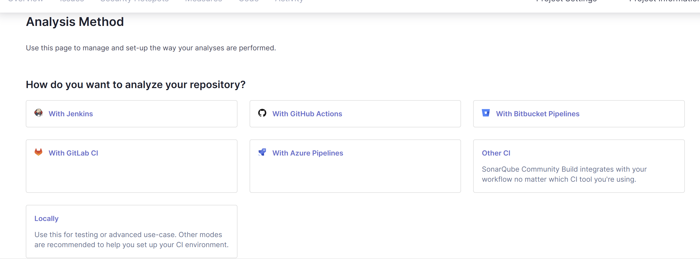
- Generate a project token
- Select the project language and your system OS
- Now, let’s download the scanner to scan our codebase from this link https://docs.sonarsource.com/sonarqube-community-build/analyzing-source-code/scanners/sonarscanner/
- Extract the zip into C:// directory
- Add the bin folder inside it to your ENV variables
- Now, we are ready to run the scanner. Go to the project codebase directory, open CMD with admin rights and run the command generated in step 10 UI (under ‘Execute the Scanner’ subsection). 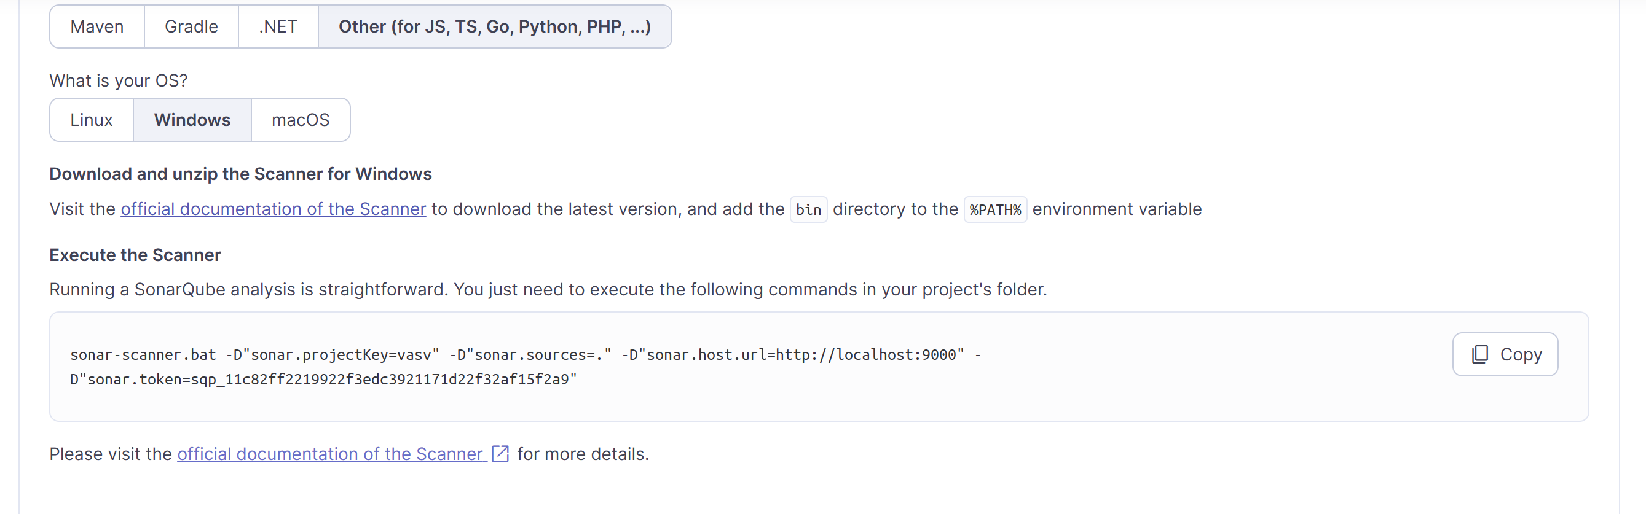
- Once the scanner finishes execution in CMD, the analysis results get updated in the SonarQube server UI 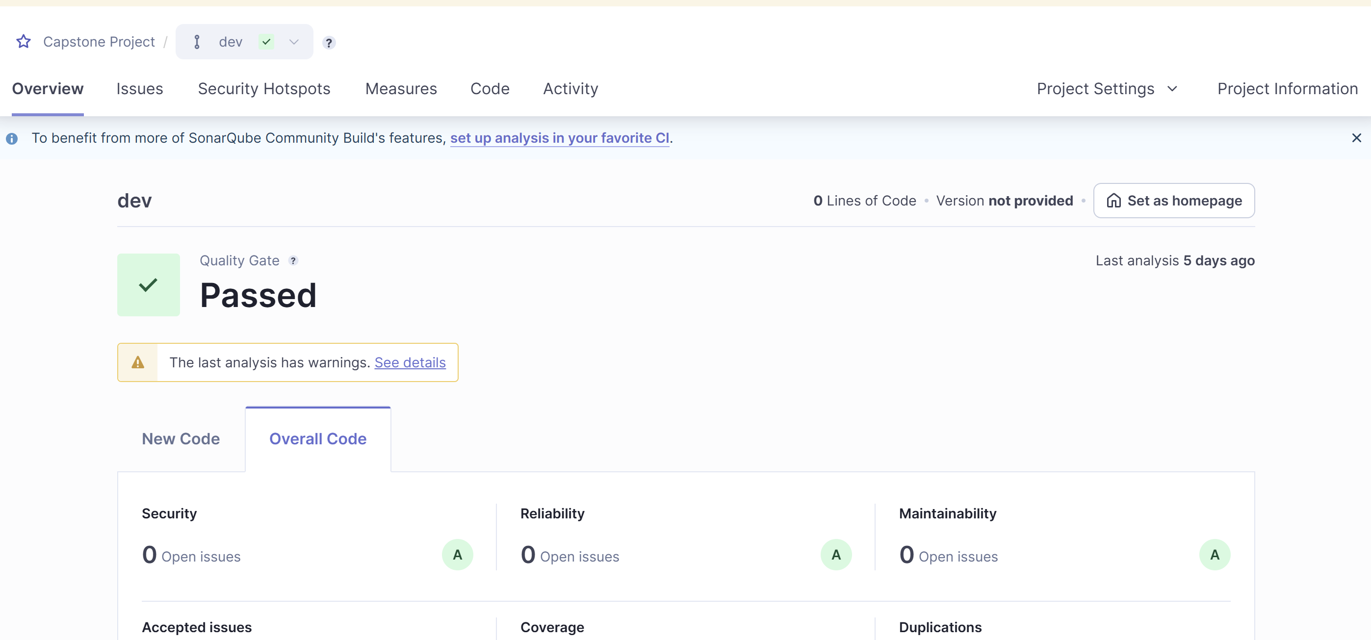
The plot module in finrl provides various utility functions for analyzing and visualizing financial trading strategies. Below is a breakdown of the key functions:
1. get_daily_return(df, value_col_name="account_value")
- Purpose: Computes the daily return from an account value dataframe.
- Parameters:
  - df: A pandas dataframe containing account values over time.
  - value_col_name: The column name that holds the account values (default: "account_value").
- Process:
  - Creates a deep copy of df.
  - Computes the percentage change between consecutive days using .pct_change(1).
  - Converts the "date" column to a datetime format and sets it as the index.
  - Ensures the index is localized to UTC.
- Returns: A pandas Series containing the daily returns indexed by date.

2. convert_daily_return_to_pyfolio_ts(df)
- Purpose: Converts the daily return data into a format compatible with pyfolio, a portfolio performance analysis library.
- Parameters:
  - df: A pandas dataframe containing at least a "date" column and a "daily_return" column.
- Process:
  - Converts the "date" column to datetime and sets it as the index.
  - Localizes the index to UTC.
  - Removes the "date" column from the dataframe.
  - Returns a pandas Series of daily returns.
- Returns: A pandas Series formatted for pyfolio.
3. backtest_stats(account_value, value_col_name="account_value")
- Purpose: Computes and prints backtesting performance statistics using pyfolio.
- Parameters:
  - account_value: A pandas dataframe containing the trading account values.
  - value_col_name: The column name for account values (default: "account_value").
- Process:
  - Calls get_daily_return() to calculate daily returns.
  - Uses pyfolio.timeseries.perf_stats() to compute key performance metrics.
- Returns: The computed performance statistics.

4. backtest_plot(account_value, baseline_start, baseline_end, baseline_ticker, value_col_name="account_value")
- Purpose: Generates a backtesting report using pyfolio, comparing the strategy's returns with a baseline (benchmark).
- Parameters:
  - account_value: A pandas dataframe with account values over time.
  - baseline_start: The start date for fetching benchmark data.
  - baseline_end: The end date for fetching benchmark data.
  - baseline_ticker: The stock/index ticker symbol for the benchmark (default: "^DJI" for the Dow Jones Industrial Average).
  - value_col_name: The column name for account values (default: "account_value").
- Process:
  - Computes daily returns for the strategy.
  - Fetches historical data for the benchmark using get_baseline().
  - Computes daily returns for the benchmark.
  - Calls pyfolio.create_full_tear_sheet() to generate a detailed report.
- Returns: None (displays a full Pyfolio tear sheet with visualizations and statistics).
5. get_baseline(ticker, start, end)
- Purpose: Fetches historical stock/index data as a benchmark for comparison.
- Parameters:
  - ticker: The stock/index ticker symbol (e.g., '^DJI' for the Dow Jones Industrial Average).
  - start: The start date for fetching data.
  - end: The end date for fetching data.
- Process:
  - Uses YahooDownloader to fetch data from Yahoo Finance.
- Returns: A pandas dataframe containing historical price data for the given ticker.
6. trx_plot(df_trade, df_actions, ticker_list)
- Purpose: Plots transaction signals (buy/sell) on stock price charts.
- Parameters:
  - df_trade: A pandas dataframe containing stock price data.
  - df_actions: A dataframe containing trade actions.
  - ticker_list: A list of stock ticker symbols.
- Process:
  - Extracts transaction data from df_actions.
  - Identifies buy and sell signals.
  - Overlays transaction signals on price charts.
- Returns: None (displays plots with transaction markers).
Summary
These functions are essential for:
- Analyzing Trading Performance (get_daily_return, convert_daily_return_to_pyfolio_ts, backtest_stats)
- Benchmarking with Market Indexes (get_baseline, backtest_plot)
- Visualizing Trading Activity (trx_plot)

FinRL Project : Data Preprocessing

We can use the function DataProcesser for data preprocessing, including data accessing and cleaning, and feature engineering.

Data Cleaning
Raw data retrieved from different data sources are usually of various formats and have erroneous or NaN data (missing data) to different extents, making data cleaning highly time-consuming. In FinRL-Meta, we automate the data cleaning process.
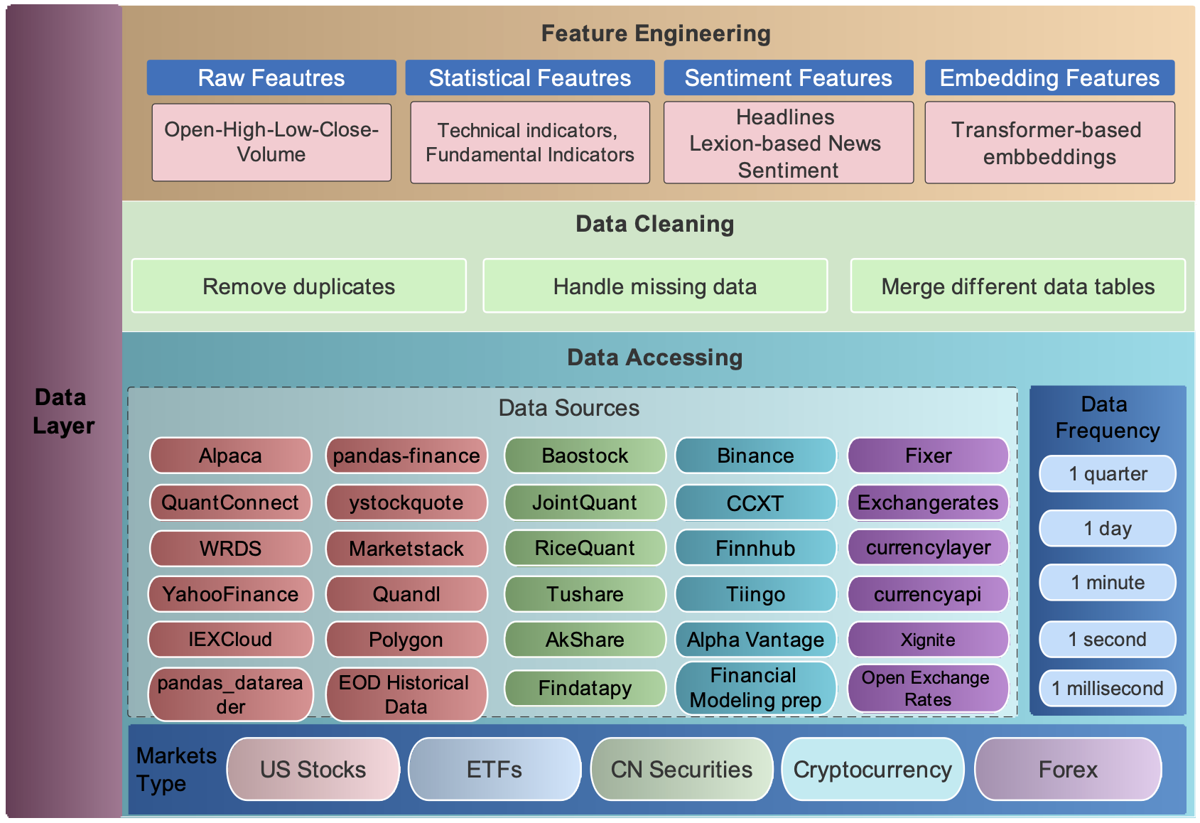
NaN Datas:
NaN data are usually different for various time frequencies. For Low-frequency data, except few stocks with extremely low liquidity, the few NaN values usually mean suspension during that time interval. While for high-frequency data, NaN values are pervasive, which usually means no transaction during that time interval. To reduce the simulation-to-reality gap considering of data efficiency, we provide different solutions for these two cases.
- In the low-frequency case, we directly delete the rows with NaN values, reflecting suspension in simulated trading environments.
- On OHLCV: The low data efficiency of the dropping method is unacceptable. Instead, we take an improved forward filling method. We fill the open, high, low, close columns with the last valid value of close price and the volume column with 0, which is a standard method in practice.
Adding Technical Indicators
We automate the calculation of technical indicators by connecting the Stockstats or TAlib library in our data processor. Common technical indicators including Moving Average Convergence Divergence (MACD), Relative Strength Index (RSI), Average Directional Index (ADX), and Commodity Channel Index (CCI), and so on, are supported. Users can also quickly add indicators from other libraries, or add the user-defined features directly.

You can add technical indicators and turbulence factor to dataframe. Just set the use_technical_indicator=True, use_vix=True and use_turbulence=True
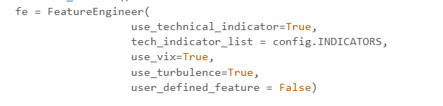

Define Environment Parameters (env_kwargs)
We automate the setup of the trading environment by defining env_kwargs, which controls how the reinforcement learning (RL) agent interacts with the market. Key parameters such as the state space, action space, initial capital, transaction costs, and reward scaling can be customized to fit different trading strategies.
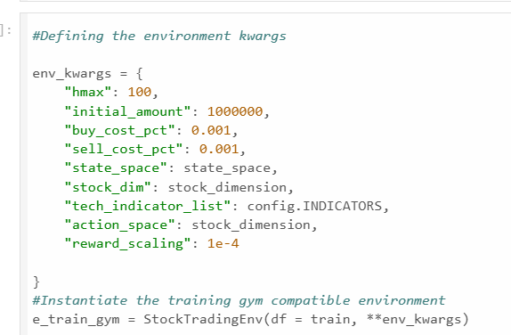
These parameters configure how the environment behaves and what the agent interacts with:
- "hmax": The maximum number of shares that can be traded in a single transaction (prevents unrealistic trading).
- "initial_amount": The starting capital for the agent in the simulation.
- "buy_cost_pct" and "sell_cost_pct": Transaction fees as a percentage, adding realism to the simulation.
- "state_space": The input size (number of features) that defines the agent's observations.
- "stock_dim": The number of different stocks included in the simulation environment.
- "tech_indicator_list": A list of technical indicators (e.g., RSI, MACD) used as features for decision-making.
- "action_space": The number of stocks the agent can trade, matching the stock dimension.
- "reward_scaling": A scaling factor applied to rewards to normalize their magnitude and stabilize training.

The Custom Functions to be used in Preprocessing
Users can add their features by two ways:
1) Write user-defined feature extraction functions directly. The returned features will be added to a feature array.
2) Store the features in a file, and move it to a specified folder. Then, these features will be obtained by reading from the specified file.

FinRL provides FeatureEngineer, which you can extend to define custom feature extraction methods.

Backtest Analysis: backtest_stats and backtest_plot
Overview
Backtesting is a crucial step in evaluating trading strategies. The functions backtest_stats and backtest_plot help assess a strategy's performance using historical data.
backtest_stats
This function computes statistical metrics for backtesting performance. It extracts daily returns from the account value and uses pyfolio to generate key performance indicators.
Key Metrics:
- Annual Return: Measures yearly profitability.
- Sharpe Ratio: Assesses risk-adjusted returns.
- Max Drawdown: Identifies the worst peak-to-trough decline.
- Volatility: Measures return fluctuations.
Usage:
perf_stats = backtest_stats(account_value)
backtest_plot
This function visualizes the backtest results by comparing the strategy's performance against a benchmark (e.g., the Dow Jones Index).
Features:
- Plots the strategy’s cumulative returns.
- Includes benchmark performance for comparison.
- Generates a full tear sheet using pyfolio.
Usage:
backtest_plot(account_value, baseline_ticker="^DJI")
These functions provide valuable insights into a strategy’s effectiveness before live deployment.

Significance of Technical Indicators in Portfolio Allocation Using FinRL
1. Introduction
In the field of financial reinforcement learning (FinRL), portfolio allocation is a crucial aspect of maximizing returns while minimizing risk. Technical indicators play a significant role in aiding reinforcement learning (RL) agents by providing structured, data-driven signals. These indicators help in identifying market trends, momentum, volatility, and price movements, enabling the agent to make informed investment decisions.
2. Why Are Technical Indicators Important in Portfolio Allocation?
2.1 Enhancing Decision-Making in Reinforcement Learning
- RL agents learn from historical data to optimize future trades.
- Technical indicators provide structured signals to help the model make decisions on asset allocation—whether to buy, sell, or hold.
2.2 Identifying Market Trends for Smart Allocation
- Indicators like MACD, Bollinger Upper Band (boll_ub), Bollinger Lower Band (boll_lb) help determine uptrends or downtrends.
- MACD (Moving Average Convergence Divergence) helps traders identify changes in momentum by comparing two moving averages of asset prices.
- Bollinger Bands (boll_ub & boll_lb) provide a dynamic range of price movement, helping identify overbought and oversold conditions.
- The FinRL agent can allocate more weight to trending stocks and reduce exposure to declining ones.
2.3 Reducing Portfolio Volatility
- DX_30 (Directional Movement Index) measures price fluctuations and helps determine trend strength.
- FinRL dynamically adjusts portfolio allocation to avoid high-risk assets during volatile market periods.
2.4 Detecting Overbought and Oversold Conditions
- RSI_30 (Relative Strength Index) is used to determine whether a stock is overbought or oversold, helping in portfolio rebalancing.
- CCI_30 (Commodity Channel Index) measures price deviation from its statistical mean, helping detect trend reversals.
- The agent can rebalance the portfolio by adjusting allocation based on these signals.
2.5 Improving Risk-Adjusted Returns
- FinRL optimizes risk-adjusted returns using indicators like Close 30 SMA (close_30_sma) and Close 60 SMA (close_60_sma).
- SMA (Simple Moving Average) smoothens price fluctuations and helps detect overall trend direction.
- Combining these indicators with reinforcement learning helps construct a more stable and profitable portfolio.
3. Commonly Used Technical Indicators in FinRL
Indicator | Purpose
MACD | Measures momentum and trend direction by comparing moving averages
Bollinger Upper Band (boll_ub) | Identifies potential price breakouts above a dynamic range
Bollinger Lower Band (boll_lb) | Identifies potential price rebounds below a dynamic range
RSI_30 | Detects overbought/oversold conditions and signals potential reversals
CCI_30 | Measures price deviation from statistical mean to identify trend reversals
DX_30 | Measures the strength of a trend and identifies directional movement
Close 30 SMA (close_30_sma) | Identifies short-term price trends and smoothens volatility
Close 60 SMA (close_60_sma) | Identifies medium-term price trends for more stable predictions
4. How FinRL Uses Technical Indicators for Portfolio Allocation
4.1 Feature Engineering
- FinRL extracts technical indicators from historical price data and converts them into state-space representations for RL agents.
4.2 State Representation in RL
- The agent learns market dynamics using technical indicators as features to determine the best asset allocation strategy.
4.3 Action Selection (Portfolio Weights)
- Based on the indicators, the RL agent determines whether to allocate, hold, or rebalance assets in the portfolio.
4.4 Risk Management and Reward Maximization
- The model considers risk-adjusted reward metrics and uses indicators to mitigate losses during high volatility periods.
5. Conclusion
Technical indicators provide valuable insights that help FinRL models make intelligent portfolio allocation decisions. They enable the RL agent to adapt to changing market conditions, optimize returns, and manage risk efficiently. By integrating reinforcement learning with technical indicators, financial models can achieve data-driven, adaptive portfolio management that enhances decision-making and profitability.
6. Future Scope
- Exploring the combination of fundamental and technical indicators.
- Improving FinRL models using advanced deep reinforcement learning techniques.
- Automating real-time portfolio adjustments using FinRL-powered AI agents.

